CAD PPE

Hands-on Lab – Day 1

Modern App

October 2016

© 2016 Microsoft Corporation. All rights reserved. This document is confidential and proprietary to Microsoft. Internal use only. This document is for informational purposes only. MICROSOFT MAKES NO WARRANTIES, EXPRESS OR IMPLIED, IN THIS SUMMARY.

This document is provided "as-is." Information and views expressed in this document, including URL and other Internet Web site references, may change without notice. You bear the risk of using it.

Some examples are for illustration only and are fictitious. No real association is intended or inferred.

Contents

Modern cloud apps hackathon 1

Exercise 0: Environment setup 1

Task 1: Setup a Development Environment 1

Task 2: Download and explore the Contoso Sports League sample 1

Task 3: Create a new Azure Resource Group 2

Exercise 1: Proof of concept deployment 3

Overview 3

Help references 3

Task 1: Deploy the e-commerce website, SQL database, and storage 3

Task 2: Setup SQL Database Geo-Replication 14

Task 3: Deploying the call center admin website 26

Task 4: Deploying the payment gateway 30

Task 5: Deploying the offers Web API 33

Task 6: Update and deploy the e-commerce website 38

Exercise 2: Automating backend processes 42

Overview 42

Help references 42

Task 1: Enable receipt generation 42

Task 2: Order Notifications 48

Exercise 3: Enabling Telemetry with Application Insights 60

Overview 60

Help references 60

Task 1: Configure the application for telemetry 61

Task 2: Creating the web performance test and load test 67

Exercise 4: Identity and security 72

Overview 72

Help references 73

Task 1: Enable Azure AD Premium Trial 73

Task 2: Create a new Contoso user 75

Task 3: Configure access control for the call center administration web application 76

Task 4: Apply custom branding for the Azure Active Directory logon page 80

Exercise 5: SQL Data Warehouse 82

Overview 82

Help references 82

Task 1: Create SQL Data Warehouse 83

Task 2: Configure Azure Data Factory 90

# Modern cloud apps hackathon

## Exercise 0: Environment setup

In this exercise, you will set up an environment to use for the rest of the exercises.

### Task 1: Setup a Development Environment

**Before moving forward with this document, you need to complete the steps described on the** [CAD PPE Hands-on Lab Setup Guide](https://aka.ms/mabenoit/cad-ppe-lab-setup)**.**

### Task 2: Download and explore the Contoso Sports League sample

1. Create a new folder on your C: drive named **Hackathon**.
2. Download the sample application (modern-cloud-apps-student.zip) from here: <http://bit.ly/1MqHXMb> and extract to the **Hackathon** folder.

Note: The link above is case sensitive.

1. From the **Contoso Sports League** folder under **Hackathon**, open the Visual Studio Solution file: **Contoso.Apps.SportsLeague.sln**.
2. The solution contains the following projects:

|  |  |
| --- | --- |
| Contoso.Apps.SportsLeague.Web | Contoso Sports League e-commerce application |
| Contoso.Apps.SportsLeague.Admin | Contoso Sports League call center admin application |
| Contoso.Apps.SportsLeague.WorkerRole | Handles receipt generation for orders |
| Contoso.Apps.SportsLeague.Data | Data tier |
| Contoso.Apps.SportsLeague.Offers | API for returning list of available products |
| Contoso.Apps.PaymentGateway | API for payment processing |

### Task 3: Create a new Azure Resource Group

1. Within the Azure Management Portal, open the **Resource groups** tile and click **Add**.

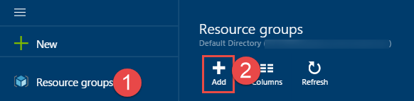

1. Specify the name of the resource group as **contososports**, and choose the Azure region you want to deploy the lab to. This resource group will be used throughout the rest of the lab. Click **Create** to create the resource group.

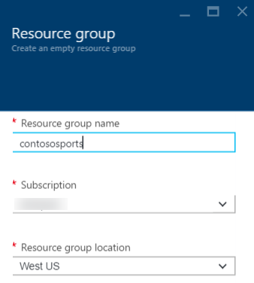

## Exercise 1: Proof of concept deployment

### Overview

Contoso has asked you to create a proof of concept deployment in Microsoft Azure by deploying the web, database, and API applications for the solution and then validating that the core functionality of the solution works. Ensure all resources use the same resource group that was created for the App Service Environment.

### Help references

|  |  |
| --- | --- |
| SQL firewall | <https://azure.microsoft.com/en-us/documentation/articles/sql-database-configure-firewall-settings/> |
| Deploying a web app | <https://azure.microsoft.com/en-us/documentation/articles/web-sites-deploy/> |
| Deploying an API app | <https://azure.microsoft.com/en-us/documentation/articles/app-service-dotnet-deploy-api-app/> |
| Accessing an API app from a JavaScript client | <https://azure.microsoft.com/en-us/documentation/articles/app-service-api-javascript-client/> |
| SQL Database Geo-Replication overview | <https://azure.microsoft.com/en-us/documentation/articles/sql-database-geo-replication-overview/> |

### Task 1: Deploy the e-commerce website, SQL database, and storage

In this exercise, you will provision a website via the Azure Web App + SQL template using the Microsoft Azure Portal. You will then edit the necessary configuration files in the starter project and deploy the e-commerce website.

#### Subtask 1: Create the web app and SQL database instance

1. From the Azure Management portal <http://portal.azure.com>, using a new tab or instance, navigate to create **Web App + SQL**.
2. Click **New**, and in the Marketplace search text box enter **Web App +**. Click the **Web App + SQL** item in the search results.

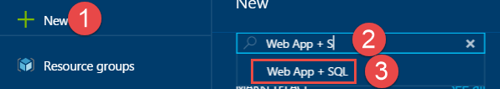

1. On the **Everything** blade select **Web App + SQL**.

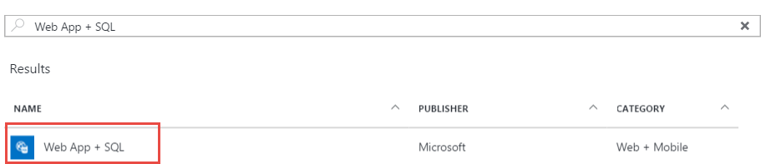

1. Check the box to pin to the dashboard, and then click **Create**.

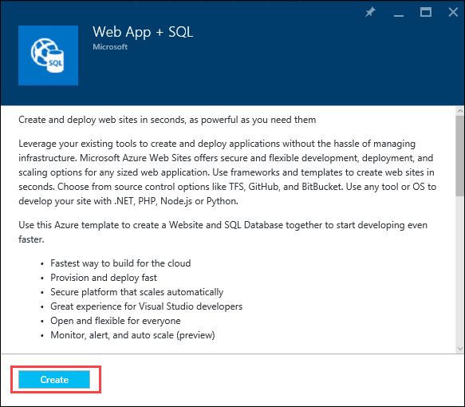

1. On the **Web App + SQL** blade select **App Service plan/Location, *Configure required settings***.

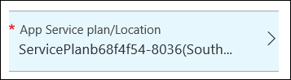

1. On the Web App blade specify the following configuration:
   1. Specify a unique and valid URL (until the green check mark appears)
   2. Specify the **contososports** resource group.
   3. Specify the name **ContosoSportsPlan** as the App Service plan and choose the same location as the Resource Group.

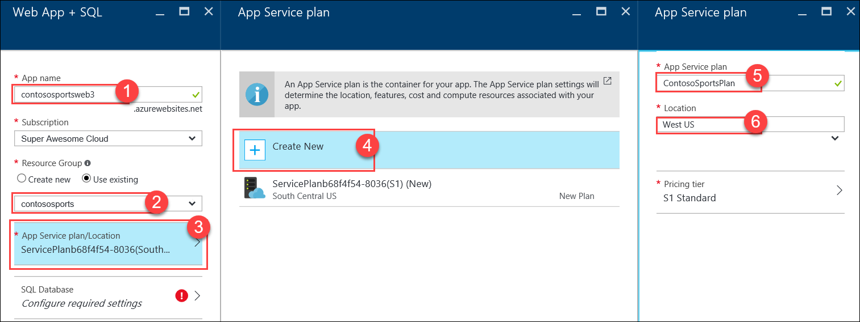

1. Click **OK** to save the configuration.

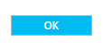

1. Select **SQL Database *Configure required settings***.

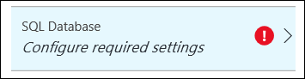

1. On the **SQL Database** blade, specify **ContosSportsDB** as the database name.

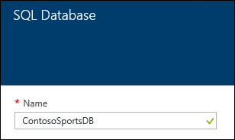

1. On the **SQL Database** blade, select **Target** **Server *Configure required settings***.

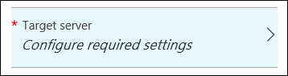

1. On the **New server** blade, specify the following configuration:
   1. Server name: a unique value (ensure the green checkmark appears)
   2. Server admin login: **demouser**
   3. **Password** and **Confirm Password**: demo@pass123
   4. Ensure the **Location** is the same region as the web app.

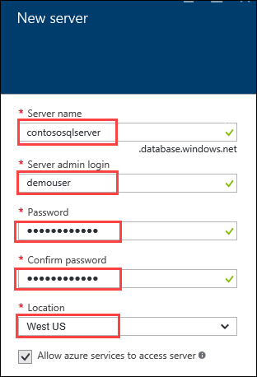

1. Once the values are accepted in the **New server** blade click **Select**.



1. On the **SQL Database** blade, click **Select**.



1. After the values are accepted click **Create**.



1. After the Web App and SQL Database are provisioned, click **More services**, **SQL databases**, and then click the name of the SQL Database you just created.

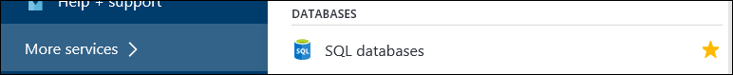

1. On the **SQL Database** blade, click the **Show database connection strings** link.

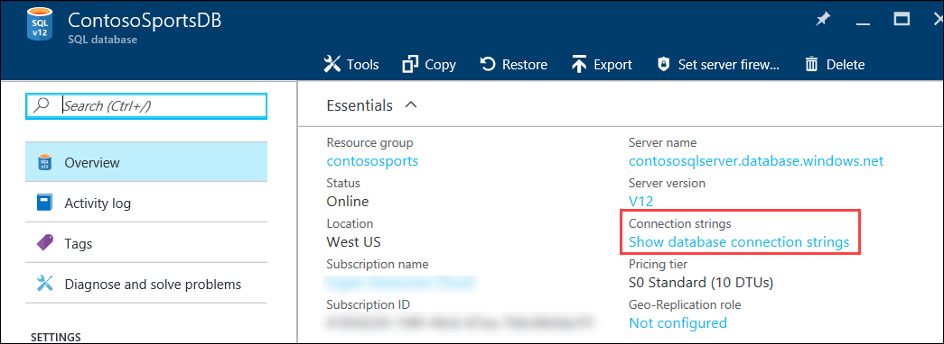

1. On the **Database connection strings** blade select the **ADO.NET (SQL authentication)** connection string and save the value in Notepad by clicking **Click to copy** for later use or simply highlight the string and copy (**Ctrl+C**) and paste (**Ctrl+V**) in Notepad.

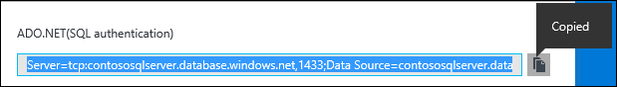

1. Click the SQL Database server name link.

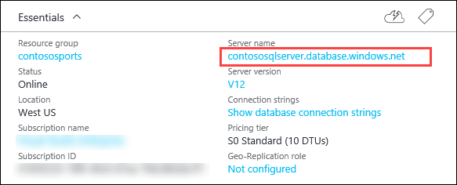

1. On the **SQL Server** blade under **Firewall,** click **Show firewall settings**.

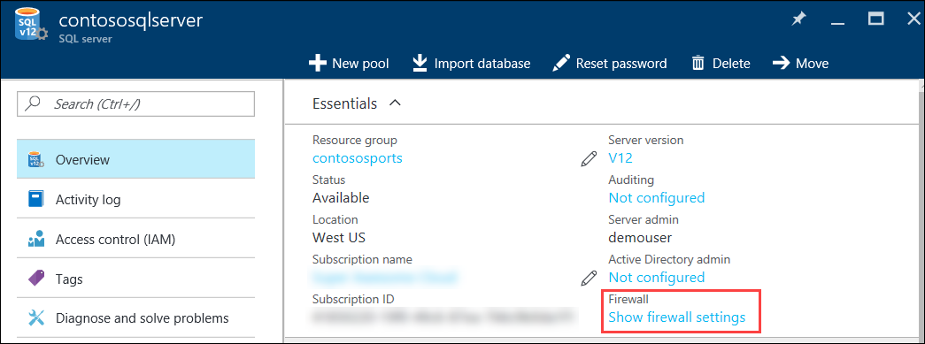

1. On the **Firewall Settings** blade, specify a new rule named **ALL**, with START IP **0.0.0.0**, and END IP **255.255.255.255**.

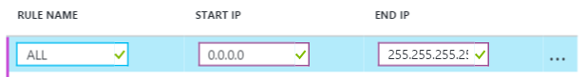

1. Click **Save**.

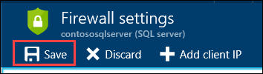

1. On the **Success!** dialog box click **OK**.

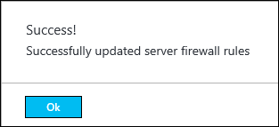

1. Close all configuration blades.

#### Subtask 2: Provision the storage account

1. Using a new tab or instance of your browser navigate to the Azure Management portal <http://portal.azure.com>.
2. Click **+New, Storage, Storage account.**

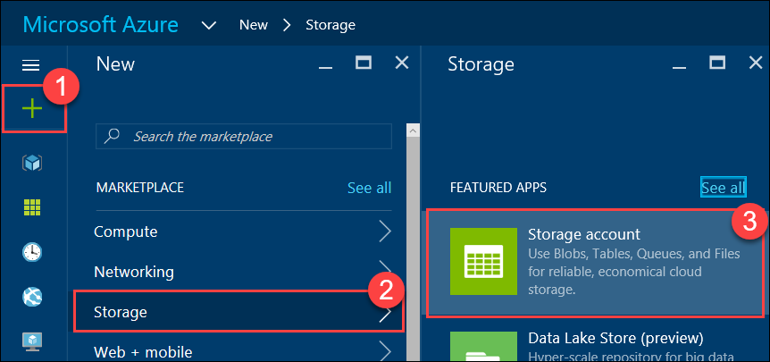

1. On the Create storage account blade specify the following configuration options:
   1. Name: unique value for the storage account (ensure the green check mark appears)
   2. Specify the Resource Group **contososports**
   3. Specify the same **Location** as the resource group.

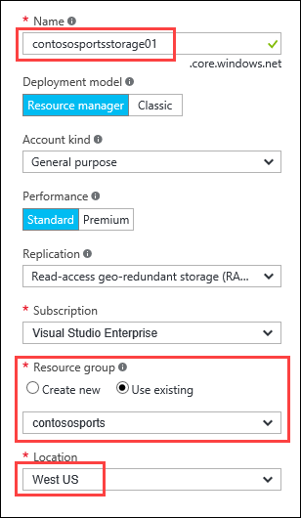

1. Click **Create**.

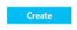

1. After the storage, account has completed provisioning open the storage account by clicking **More services,** **Storage accounts**, and then click the storage account name.

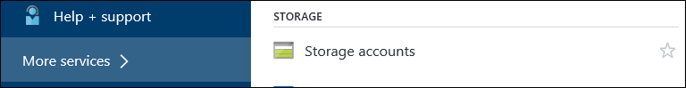

1. On the **Storage account** blade, click **All** **settings**.

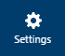

1. On the **Settings** blade, select **Access Keys**.

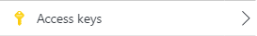

1. On the **Access keys** blade click the ellipse button by **key1.**

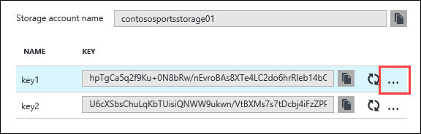

1. Then click **View Connection String**, and copy the value to the clipboard by selecting the value and pressing **CTRL-C**. Put the value in notepad for later reference.

#### Subtask 3: Update the configuration in the starter project

1. Open the Solution **Contoso.Apps.SportsLeague** in Visual Studio, by double-clicking the C:\Hackathon\Contoso Sports League\Contoso.Apps.SportsLeague solution file.
2. Navigate to the **Contoso.Apps.SportsLeague.Web** project located in the **Web** folder using the **Solution Explorer** in Visual Studio.

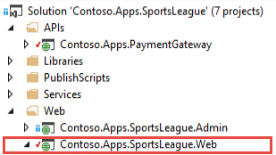

1. Expand the **Contoso.Apps.SportsLeague.Web** project and open the **web.config** file.

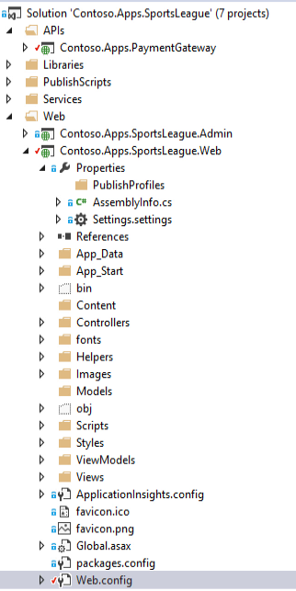

1. In the web.config file, locate the <connectionStrings> element.



1. Add the ADO.NET SQL connection string you saved earlier to ContosoSportsLeague.



Ensure you replace the string placeholder value {your_password_here} with the password you selected during creation (demo@pass123).



1. Locate the <appSettings> element.
2. Add the **Storage Account Primary Connection String** to the AzureQueueConnectionString key.



1. Save the **web.config** file.

#### Subtask 4: Deploy the e-commerce web app from Visual Studio

1. Navigate to the **Contoso.Apps.SportsLeague.Web** project located in the **Web** folder using the **Solution Explorer** of Visual Studio.



1. Right-click the **Contoso.Apps.SportsLeague.Web** project and click **Publish**.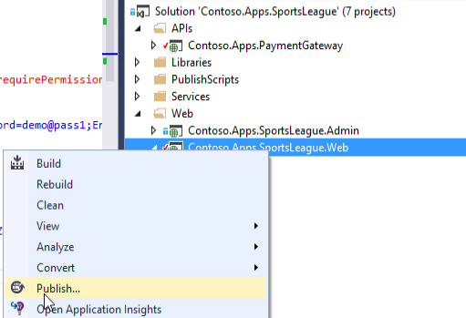
2. Choose **Microsoft Azure App Service** as the publish target.   
   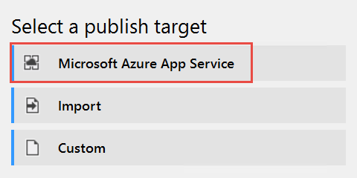
3. Log on with your credentials and ensure the subscription you published earlier is selected.

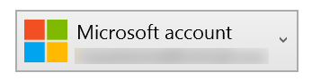

1. Select the Contoso Sports Web App.

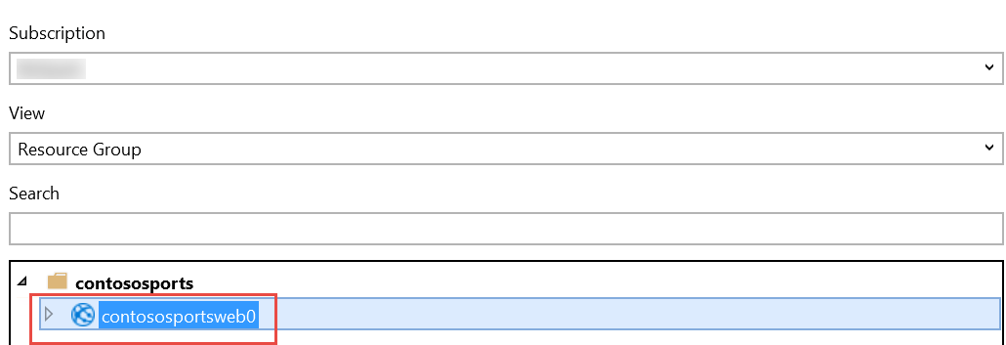

1. Click **OK**, and then click **Publish** to publish the web application.
2. In the Visual Studio **Output** view, you will see a status that indicates the web app was published successfully.  
    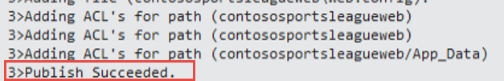
3. Validate the website by clicking the **Store** link on the menu. As long as products return, the connection to the database is successful.



### Task 2: Setup SQL Database Geo-Replication

In this exercise, the attendee will provision a secondary SQL Database and configure Geo-Replication using the Microsoft Azure Portal.

#### Subtask 1: Add secondary database

1. Using a new tab or instance of your browser navigate to the Azure Management Portal <http://portal.azure.com>
2. Click **More services, SQL databases**, and then click the name of the SQL Database you created previously.  
   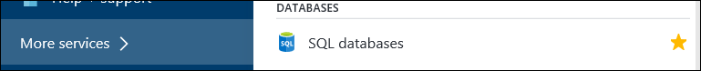
3. Under **Settings**, click **Geo-Replication**.  
   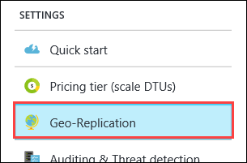
4. Select the Azure Region to place the Secondary within.  
   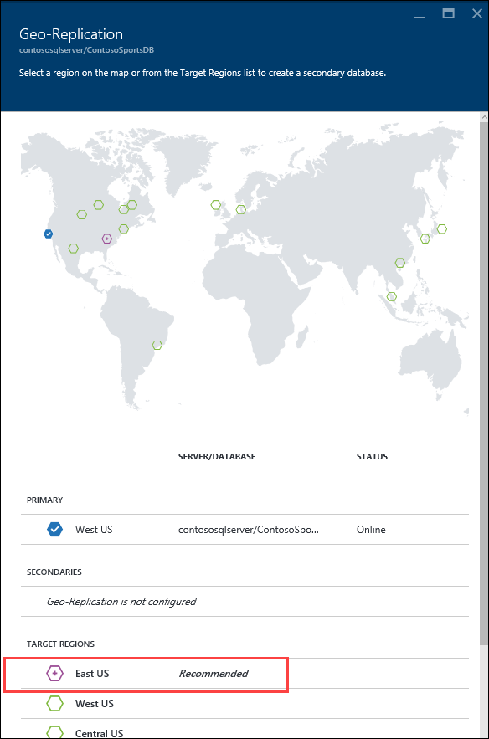

The Secondary Azure Region should be the region pair for the region the SQL Database is hosted within. The portal suggests which one to use by labeling it as “Recommended.”

1. On the **Create secondary** blade, select **Secondary Type** as **Readable**.
2. select **Target server *Configure required settings***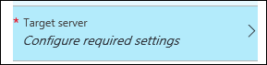
3. On the **New server** blade, specify the following configuration:
   1. Server name: a unique value (ensure the green checkmark appears)
   2. Server admin login: **demouser**
   3. **Password** and **Confirm Password**: demo@pass123

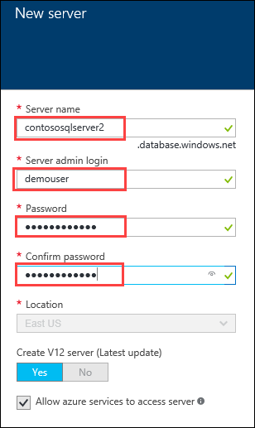

1. Once the values are accepted in the **New server** blade, click **Select**  
   
2. On the **Create secondary** blade click **OK**
3. After the Geo-Replication has finished provisioning, click **More services, SQL databases**  
   
4. Click the name of the Secondary SQL Database you just created.  
   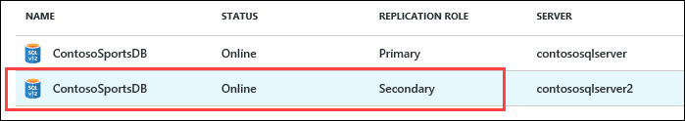
5. On the **SQL Database** blade, click the **Show database connection strings link**.  
   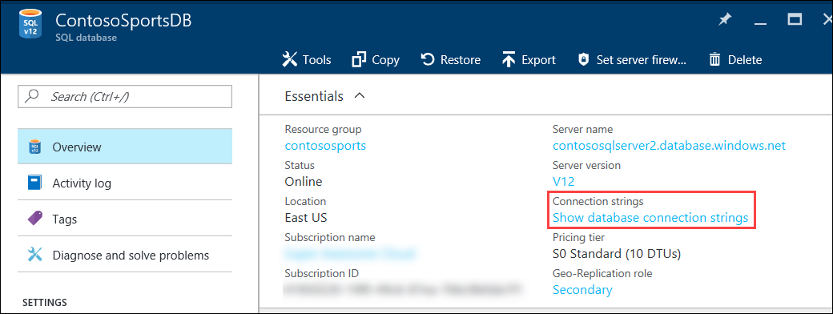
6. On the **Database connection string** blade, select the **ADO.NET (SQL authentication)** connection string and save the value in Notepad by clicking **Click to copy** for later use or simply highlight the string and copy (**Ctrl+C**) and paste (**Ctrl+V**) in Notepad.  
   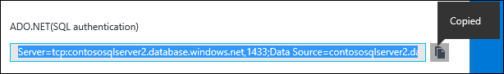
7. Click the SQL Database server name link.  
   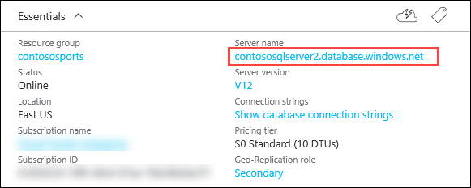
8. On the **SQL Server** blade under **Firewall,** click **Show firewall settings.**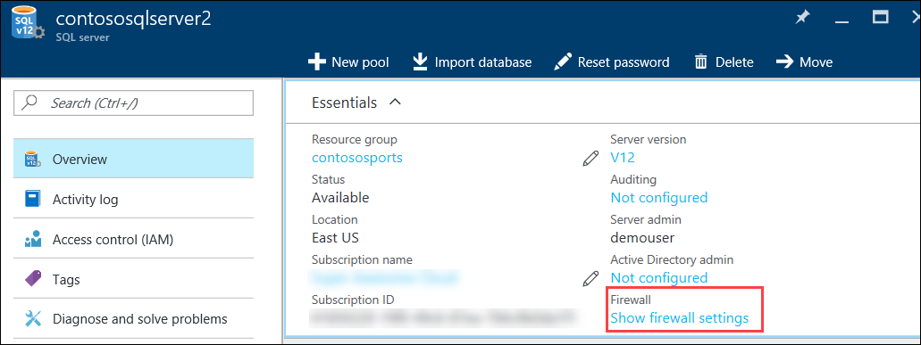
9. On the **Firewall Settings** blade, specify a new rule named **ALL**, with START IP **0.0.0.0**, and END IP **255.255.255.255**.  
   
10. Click **Save.**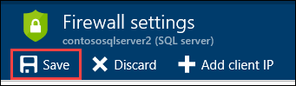
11. On the **Success!** Dialog box click **OK**.  
    
12. Close all configuration blades.

#### Subtask 2: Failover secondary SQL database

1. Using a new tab or instance of your browser navigate to the Azure Management Portal <http://portal.azure.com>
2. Click **More services, SQL databases**, and then click the name of the SQL Database you created previously  
   
3. On the **Settings** blade, click **Geo-Replication**.  
   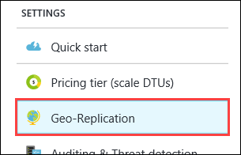
4. On the **Geo-Replication** blade, selectthe Secondary database.  
   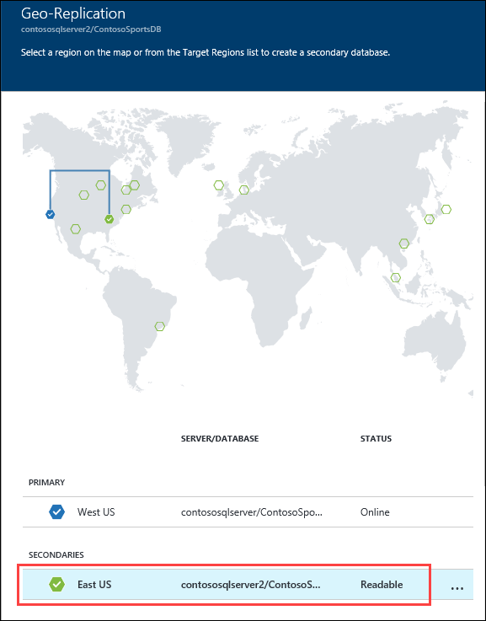
5. Click the **Failover** button.  
   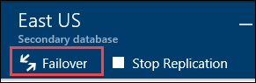
6. On the **Failover** prompt, click **Yes**.  
   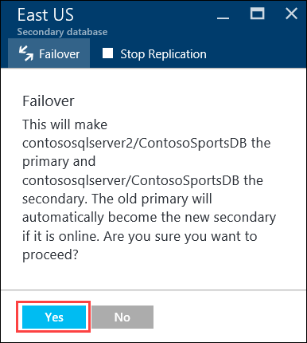

The Failover may take a few minutes to complete.

#### Subtask 3: Test e-commerce web app after Failover

1. Open the Solution **Contoso.Apps.SportsLeague** in Visual Studio, by double-clicking the C:\Hackathon\Contoso Sports League\Contoso.Apps.SportsLeague solution file.
2. Navigate to the **Contoso.Apps.SportsLeague.Web** project located in the **Web** folder using the **Solution Explorer** of Visual Studio  
   
3. Expand the **Contoso.Apps.SportsLeague.Web** project and open the **web.config** file.  
   
4. In the web.config file, locate the <connectionStrings> element.  
   
5. Add the ADO.NET SQL connection string for the Secondary database you saved earlier to ContosoSportsLeague.  
   

Ensure you replace the string placeholder value {your_password_here} with the password you selected during creation (demo@pass123).  


1. Save the **web.config** file.
2. Navigate to the **Contoso.Apps.SportsLeague.Web** project located in the **Web** folder using the **Solution Explorer** of Visual Studio.  
   
3. Right-click the **Contoso.Apps.SportsLeaque.Web** project, click **View**, and click **View in Browser.**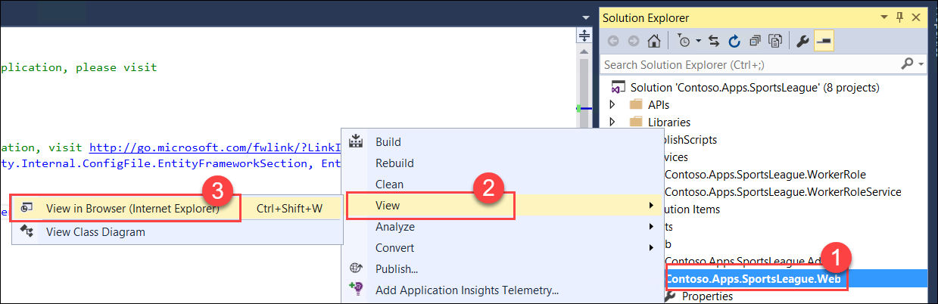

It’s possible Internet Explorer won’t be able to display the site when it comes up. If this happens, then modify the “*App_Start/FilterConfig.cs*” code file to remove the line for “*filters.Add(new RequireHttpsAttribute());*”, then navigate to the <http://localhost:45201> without SSL.

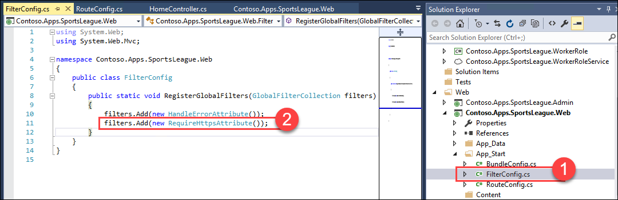

1. After the e-commerce web app loads in Internet Explorer, click **STORE** in the top navigation bar of the website.   
   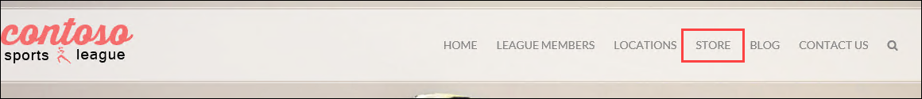
2. Verify the product list from the database displays  
   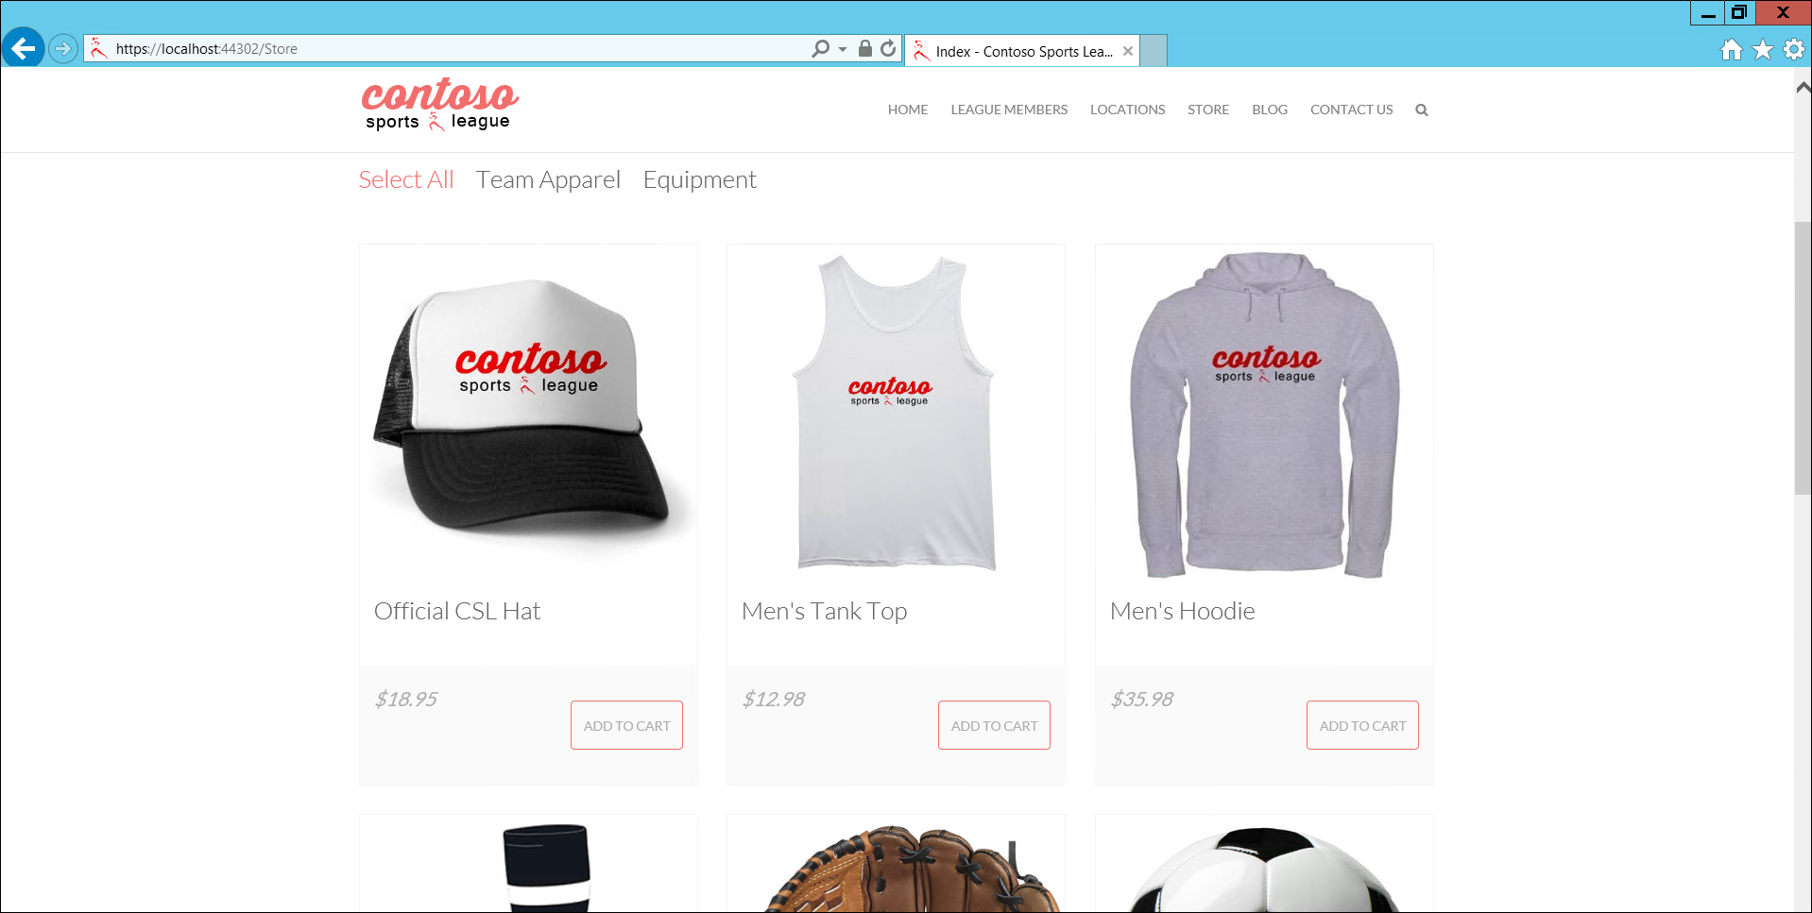

#### Subtask 4: Revert Failover back to Primary database

1. Using a new tab or instance of your browser navigate to the Azure Management Portal <http://portal.azure.com>
2. Click **More services, SQL databases**, and then click the name of the SQL Database you created previously  
   
3. On the **Settings** blade, click **Geo-Replication**.  
   
4. On the **Geo-Replication** blade, selectthe Secondary database.  
   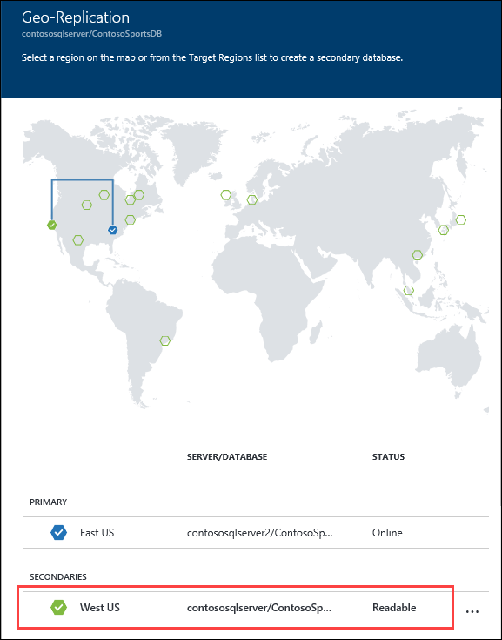
5. Click the **Failover** button.  
   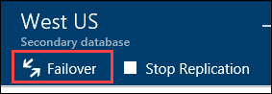
6. On the **Failover** prompt, click **Yes**.  
   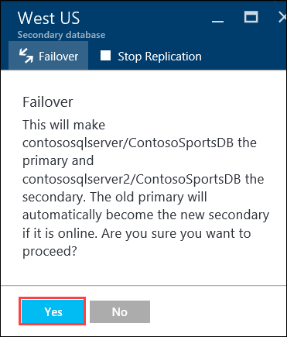

The Failover may take a few minutes to complete.

#### Subtask 5: Test e-commerce web app after reverting Failover

1. Open the Solution **Contoso.Apps.SportsLeague** in Visual Studio, by double-clicking the C:\Hackathon\Contoso Sports League\Contoso.Apps.SportsLeague solution file.
2. Navigate to the **Contoso.Apps.SportsLeague.Web** project located in the **Web** folder using the **Solution Explorer** of Visual Studio  
   
3. Expand the **Contoso.Apps.SportsLeague.Web** project and open the **web.config** file.  
   
4. In the web.config file, locate the <connectionStrings> element.  
   
5. Add the ADO.NET SQL connection string for the Primary database you saved earlier to ContosoSportsLeague.  
   

Ensure you replace the string placeholder value {your_password_here} with the password you selected during creation (demo@pass123).  


1. Save the **web.config** file.
2. Navigate to the **Contoso.Apps.SportsLeague.Web** project located in the **Web** folder using the **Solution Explorer** of Visual Studio.  
   
3. Right-click the **Contoso.Apps.SportsLeaque.Web** project, click **View**, and click **View in Browser.**
4. After the e-commerce web app loads in Internet Explorer, click **STORE** in the top navigation bar of the website.  
   
5. Verify the product list from the database displays  
   

### Task 3: Deploying the call center admin website

In this exercise, the attendee will provision a website via the Azure Web App template using the Microsoft Azure Portal. The attendee will then edit the necessary configuration files in the Starter Project and deploy the call center admin website.

#### Subtask 1: Provision the call center admin web app

1. Using a new tab or instance of your browser navigate to the Azure Management portal <http://portal.azure.com>.
2. Click **New**, **Web + mobile**, and then click **Web App** 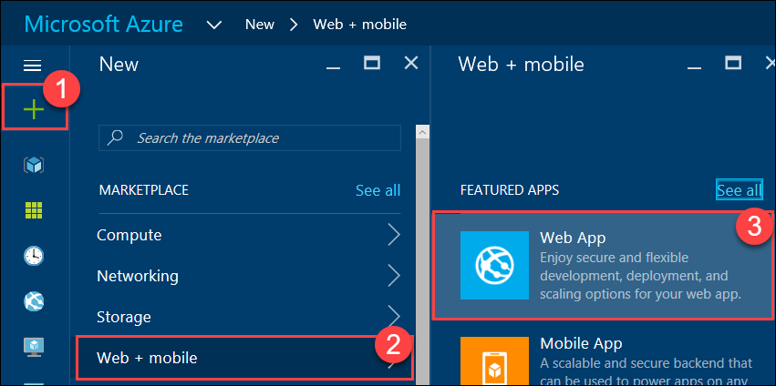
3. Specify a unique URL for the web app, and ensure the same AppService plan, and resource group that you have used throughout the lab are selected.

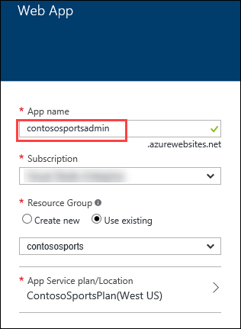

1. After the values are accepted click **Create**.



#### Subtask 2: Update the configuration in the starter project

1. Open the Solution **Contoso.Apps.SportsLeague** in Visual Studio.
2. Navigate to the **Contoso.Apps.SportsLeague.Admin** project located in the **Web** folder using the **Solution Explorer** in Visual Studio.

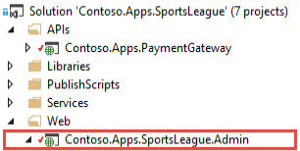

1. Expand the **Contoso.Apps.SportsLeague.Admin** project and open the **web.config** file.   
   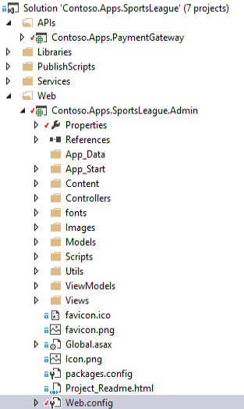
2. In the **web.config** file locate the <connectionStrings> </connectionStrings> elements.



1. Add the SQL connection string you saved earlier to the connectionString attribute of the ContosoSportsLeague connection.



1. Ensure you replace the string placeholder value **{your_password_here}** with the password you selected during creation.



1. Save the **web.config** file.

#### Subtask 3: Deploy the call center admin web app from Visual Studio

1. Navigate to the **Contoso.Apps.SportsLeague.Admin** project located in the **Web** folder using the **Solution Explorer** in Visual Studio.



1. Right-click the **Contoso.Apps.SportsLeague.Admin** project and click **Publish**.

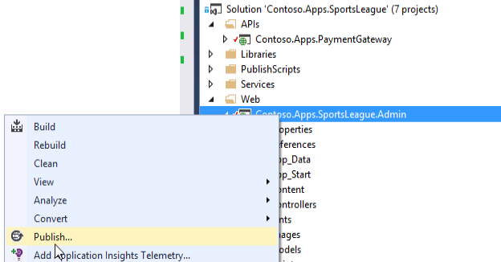

1. Choose **Microsoft Azure App Service** as the publish target.



1. Select the Contoso Sports Admin Web App.

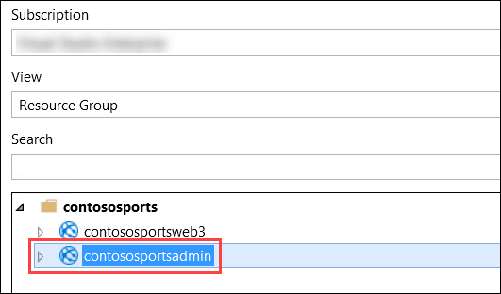

1. Click **OK**, and then click **Publish** to deploy the site.
2. The website should load and display the following:

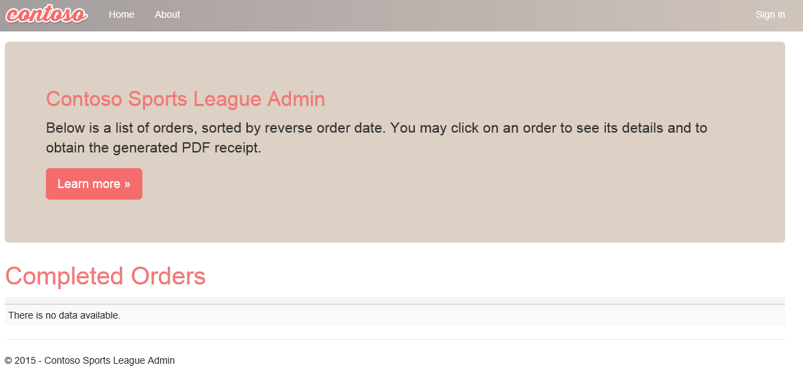

### Task 4: Deploying the payment gateway

In this exercise, the attendee will provision an Azure API app template using the Microsoft Azure Portal. The attendee will then deploy the payment gateway.

#### Subtask 1: Provision the payment gateway API app

1. Using a new tab or instance of your browser navigate to the Azure Management Portal <http://portal.azure.com>.
2. Click **+New**, **Web + mobile**, and then click **API App**.

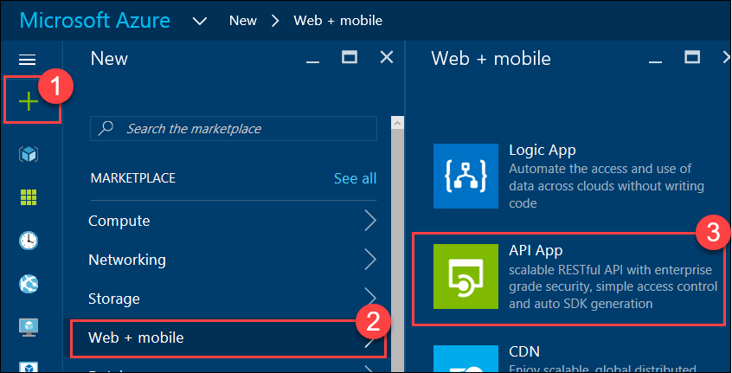

1. On the new **API App** blade, specify a unique name for the App Service Name, and ensure the previously used Resource Group and App Service Plan is selected.  
   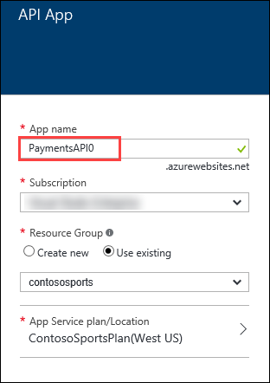
2. After the values are accepted click **Create**.  
   

#### Subtask 2: Deploy the Contoso.Apps.PaymentGateway project in Visual Studio

1. Navigate to the **Contoso.Apps.PaymentGateway** project located in the **APIs** folder using the **Solution Explorer** in Visual Studio.

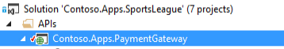

1. Right-click the **Contoso.Apps.PaymentGateway** project and click **Publish**.

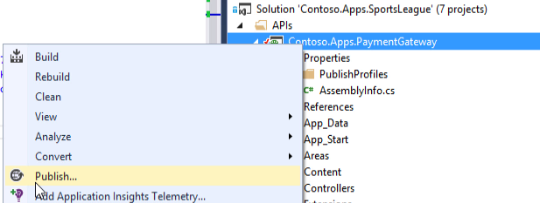

1. On the **Publish Web** dialog box,click **Microsoft Azure App Service**.

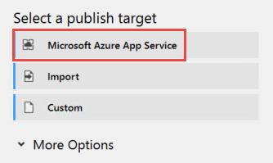

1. Select the Payment Gateway API app created earlier, click **OK**, and then **Publish**.

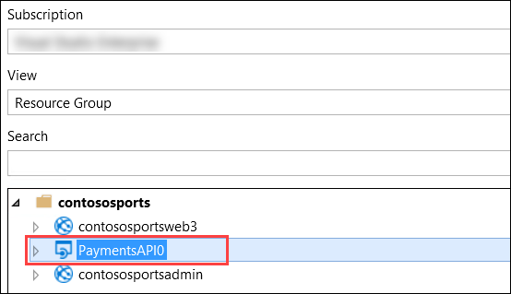

1. In the Visual Studio **Output** view, you will see a status that indicates the web app was published successfully.



1. Record the value of the deployed API app URL for later use.

### Task 5: Deploying the offers Web API

In this exercise, the attendee will provision an Azure API app template using the Microsoft Azure Portal. The attendee will then deploy the offers Web API.

#### Subtask 1: Provision the offers Web API app

1. Using a new tab or instance of your browser navigate to the Azure Management Portal (<http://portal.azure.com>).
2. Click **+New**, **Web + mobile**, and then click **API App**.



1. On the new **API App** blade, specify a unique name for the App Service Name, and ensure the previously used Resource Group and App Service Plan is selected.

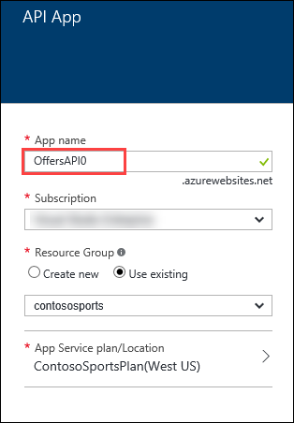

1. After the values are accepted click **Create**.  
   
2. When the web app template has completed provisioning, open the new API App by clicking **More services** -> **App Services** -> and then click the **Offers API**.

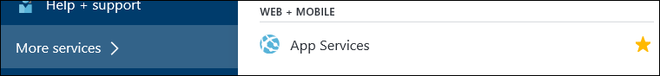

#### Subtask 2: Configure cross-origin resource sharing (CORS)

1. Under Settings, click **CORS** within the API section.

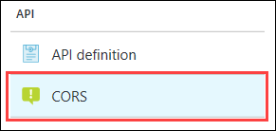

1. In the **ALLOWED ORIGINS** text box specify **\***, and click **Save**.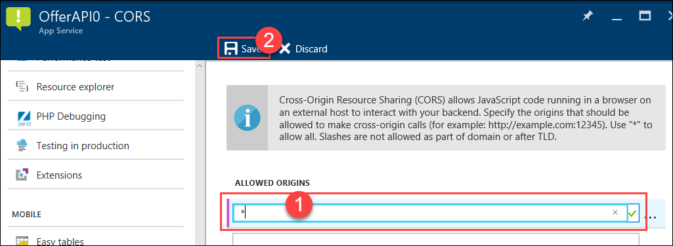

#### Subtask 3: Update the configuration in the starter project

1. Open the Solution **Contoso.Apps.SportsLeague** in Visual Studio.
2. Navigate to the **Contoso.Apps.SportsLeague.Offers** project located in the **API** folder using the **Solution Explorer** in Visual Studio.

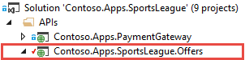

1. Expand the **Contoso.Apps.SportsLeague.Offers** project and open the **web.config** file.

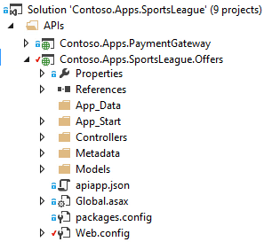

1. In the **web.config** file, locate the <connectionStrings> element.



1. Add the SQL connection string you saved earlier to ContosoSportsLeague.



1. Ensure you replace the string placeholder value **{your_password_here}** with the password you selected during creation.



1. Save the **web.config** file.

#### Subtask 4: Deploy the Contoso.Apps.SportsLeague.Offers project in Visual Studio

1. Navigate to the **Contoso.Apps.SportsLeague.Offers** project located in the **APIs** folder using the **Solution Explorer** in Visual Studio.

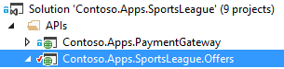

1. Right-click the **Contoso.Apps.SportsLeague.Offers** project and select **Publish**.

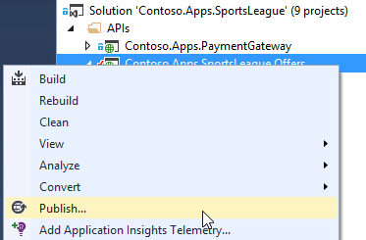

1. On the **Publish Web** dialog box,click **Microsoft Azure App Service**.



1. Select the Offers API app created earlier, click **OK**, and then **Publish**.

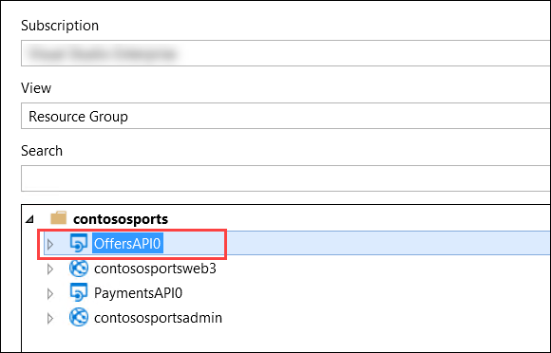

1. In the Visual Studio **Output** view, you will see a status that the API app was published successfully.
2. Record the value of the deployed API app URL for later use.



### Task 6: Update and deploy the e-commerce website

#### Subtask 1: Update the web.config file in the Contoso.Apps.SportsLeague.Web project in Visual Studio

1. Open the Solution **Contoso.Apps.SportsLeague** in Visual Studio.
2. Navigate to the **Contoso.Apps.SportsLeague.Web** project located in the **Web** folder using the **Solution Explorer** in Visual Studio.   
   
3. Expand the **Contoso.Apps.SportsLeague.Web** project and open the **web.config** file.



1. In the **web.config** file, locate the <appSettings> element.

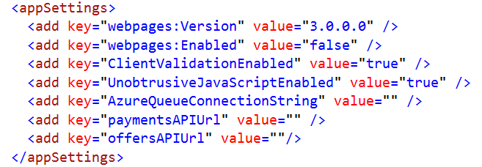

1. Update the **paymentsAPIUrl** with the URL of the published payments API. Modify the URL to use **HTTPS**, and append **/api/nvp** to the end of the URL.

Example:

<add key="paymentsAPIUrl" value="https://paymentsapi0.azurewebsites.net/api/nvp" />

1. Update the **offersAPIUrl** with the URL of the published offers API. Modify the URL to use **HTTPS**, and append **/api/get** to the end of the URL.

Example:

<add key="offersAPIUrl" value=" https://offersapi0.azurewebsites.net/api/get" />

Note: Ensure that the API URLs both are using SSL (https://) or you will see a CORS errors.

#### Subtask 2: Deploy the Contoso.Apps.SportsLeague.Web project in Visual Studio

1. Navigate to the Contoso.Apps.SportsLeague.Web project located in the **Web** folder using the **Solution Explorer** in Visual Studio.



1. Right-click **Contoso.Apps.SportsLeague.Web** and select **Publish**.   
   
2. On the **Publish Web** dialog box in the **Preview** area, you can leave the information as is and click **Publish**.
3. In the **Visual Studio Output** view, you will see a status that the web app was published successfully.
4. On the homepage, you should see the latest offers populated from the offers API.

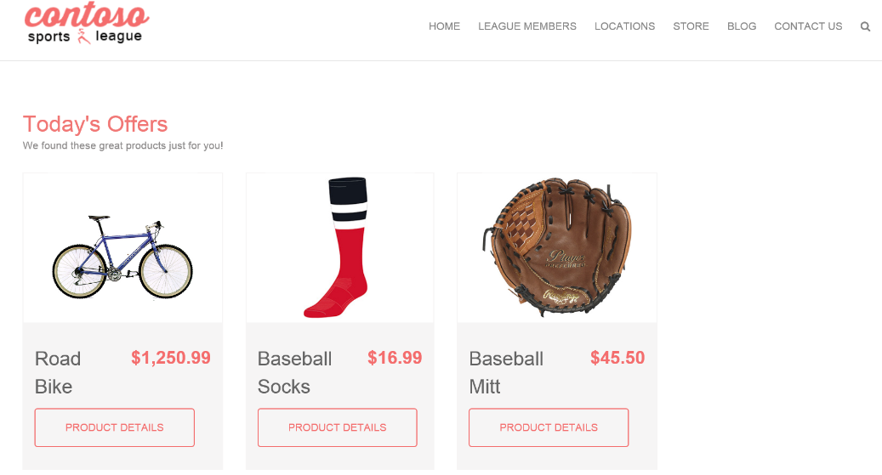

1. Submit several test orders to ensure that all pieces of the site are functional.

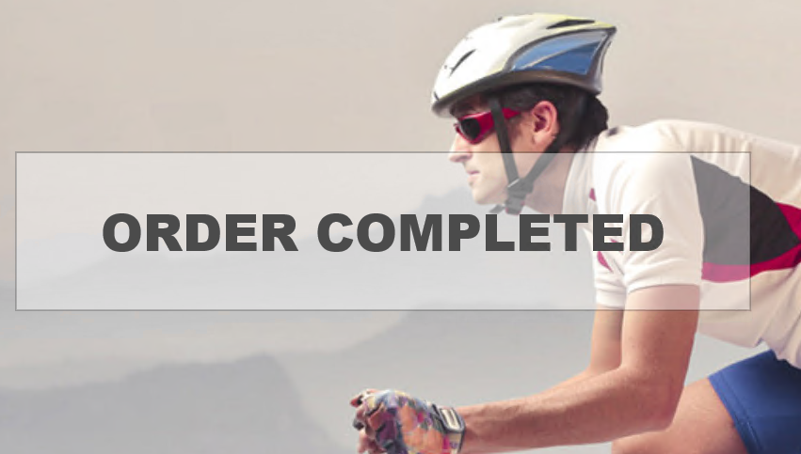

Proctor Note: If the attendee is still experiencing CORS errors ensure the URLs to the web app in Azure local host are exact.

## Exercise 2: Automating backend processes

### Overview

Contoso wants to automate the process of generating receipts in PDF format and alerting users when their orders have been processed.

### Help references

|  |  |
| --- | --- |
| Deploying an Azure Cloud Service | <https://azure.microsoft.com/en-us/documentation/articles/cloud-services-how-to-create-deploy/> |
| Creating a logic app | <https://azure.microsoft.com/en-us/documentation/articles/app-service-logic-create-a-logic-app/> |
| Logic app connectors | <https://azure.microsoft.com/en-us/documentation/articles/app-service-logic-connectors-list/> |

### Task 1: Enable receipt generation

#### Subtask 1: Update the WorkerRole and WorkerRoleService configuration files

1. Navigate to the **Contoso.Apps.SportsLeague.WorkerRole** project located in the **Services** folder using the **Solution Explorer** in Visual Studio.
2. Open the **app.config** file.

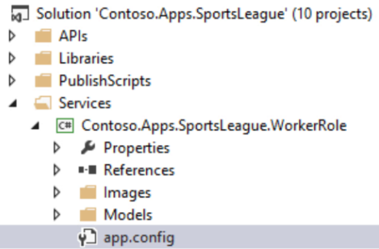

1. In the **app.config** file, locate the <connectionStrings> element.



1. Add the SQL connection string you saved earlier to **ContosoSportsLeague**. Ensure you update the password placeholder text with the real password.



1. In the **app.config** file, locate the <appSettings> element.
2. Update <add key="BlobConnectionString" value=""/>  
   with the Primary Connection String you retrieved from the storage account.
3. Save the **app.config** file.

#### Subtask 2: Create a classic Azure Storage Account

1. Click **+New**, **Storage**, and then click **Storage account**.

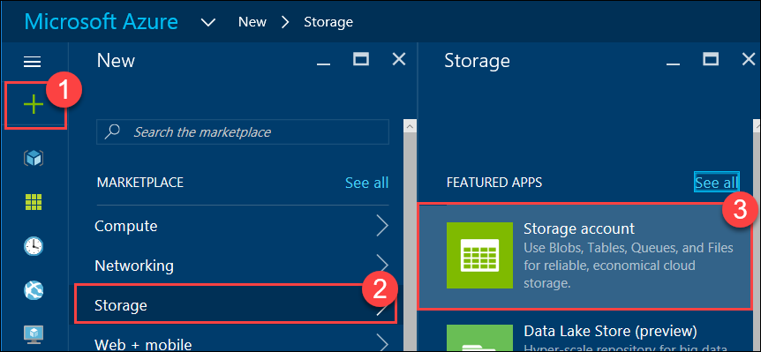

1. Specify a unique name for the **Storage account**, **Classic**, and specify the **contososports** resource group, and then click the **Create** button   
   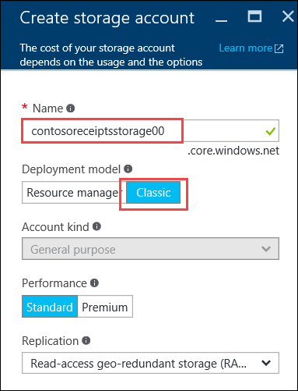

#### Subtask 3: Deploy the receipt generation worker role service

1. Right-click the **Contoso.Apps.SportsLeague.WorkerRoleService** project and select **Package**.

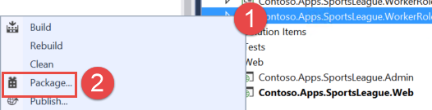

1. Accept the default options, and click **Package**.

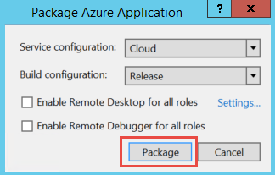

1. Note the path of the generated files.
2. Click **+New**, **Compute**, and then click **Cloud Service**.

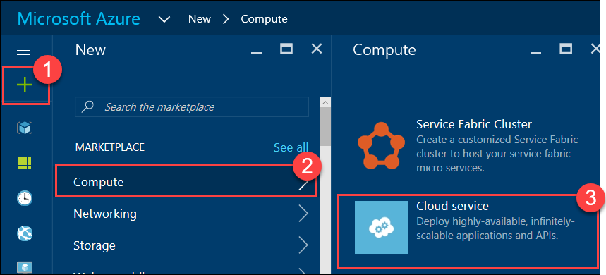

1. On the Cloud service blade, specify a **unique DNS name**, and select the existing Resource group **contososports**.   
   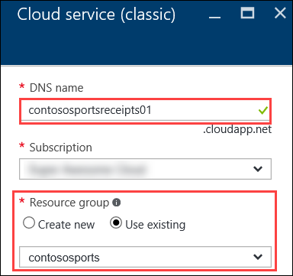
2. Click **Package**

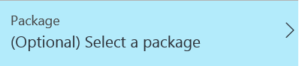

1. On the Upload a package blade, specify the following configuration options.
   1. Storage Account: **Select the classic storage account created earlier.**
   2. Deployment Label: **Production**
   3. Package: **Navigate to the Contoso.Apps.SportsLeague.WorkerRoleService.cspkg file in the package output folder from Visual Studio**.
   4. Configuration**: Navigate to the ServiceConfiguration.Cloud.cscfg file in the package output folder from Visual Studio**.
   5. Environment: **Production**

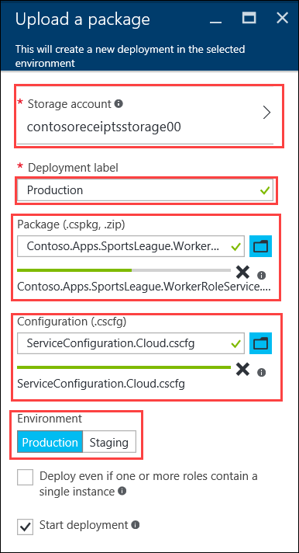

1. Click **OK**, and then **Create** to deploy the cloud services.
2. After the receipt generation service has been deployed, login to the Call Center Admin site. Click on **Details**.

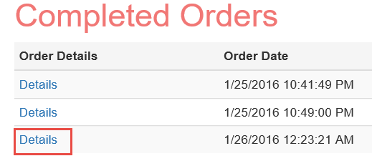

1. Verify that clicking on **Download receipt**, opens a *.pdf file of the receipt.

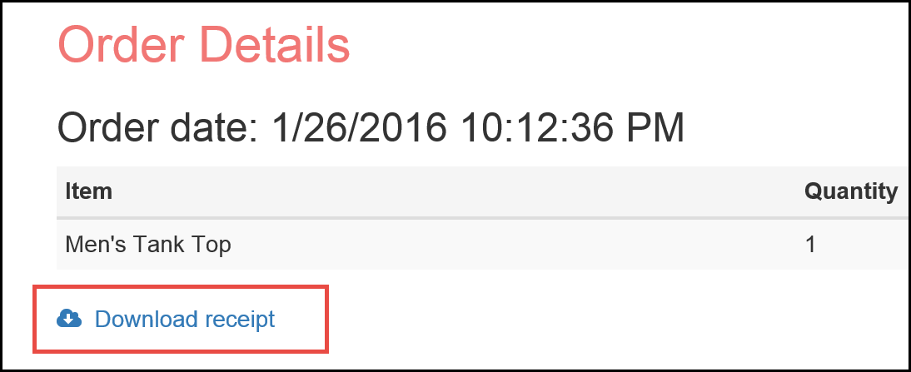

### Task 2: Order Notifications

#### Subtask 1: Configure your Twilio trial account

1. If you do not have a Twilio account, sign up for one free at the following URL:   
   [**https://www.twilio.com/try-twilio**](https://www.twilio.com/try-twilio).

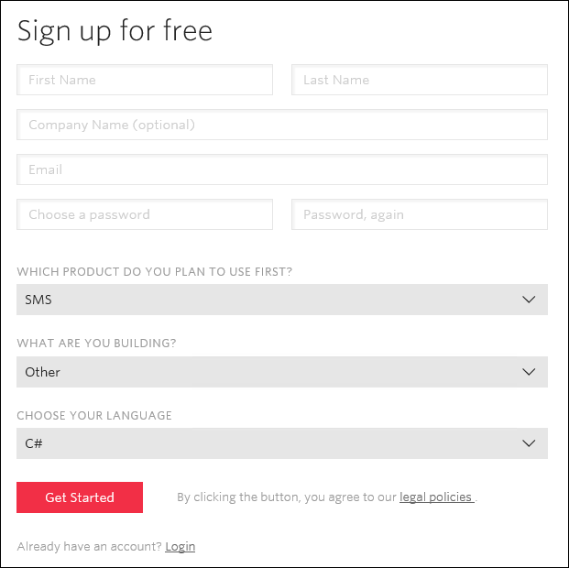

1. When you sign up for a free Twilio trial, you be asked to verify your personal phone number. This is an important security step that is mandatory for trying Twilio.  
   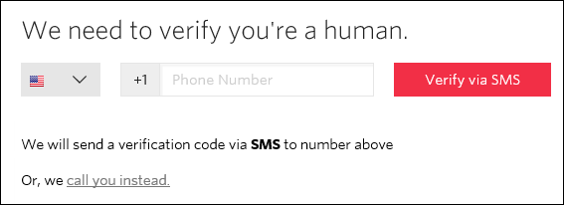
2. Click on **Phone Numbers**, and then **Get Started**.  
   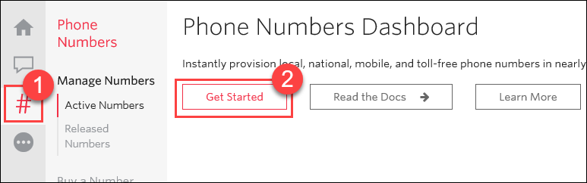
3. Click the **Get your first Twilio phone number** button.  
   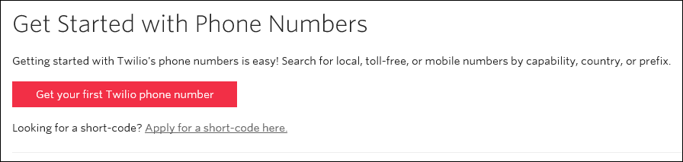
4. Record the **Phone Number**, then click the **Choose this Number** button on the Your first Twilio Phone Number prompt, and then click **Done**  
   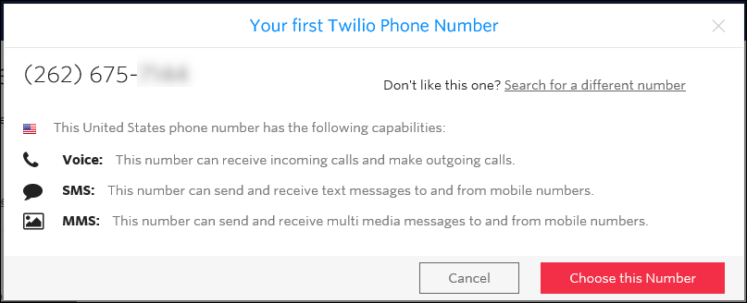
5. Click on **Home**, and then record the **Account SID** and **Auth Token** for use when configuring the Twilio Connector.  
   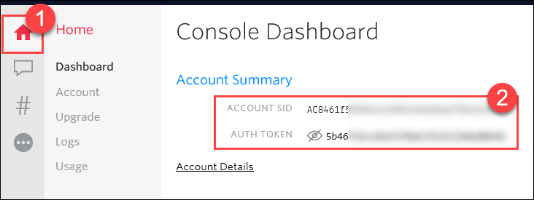

#### Subtask 2: Create a new logic app

1. Within Visual Studio, open **Server Explorer**, expand **Data Connections**, right click **ContosoSportsLeague**, and then expand **Stored Procedures**. Right click **Stored Procedures** and click **Add New Stored Procedure**.

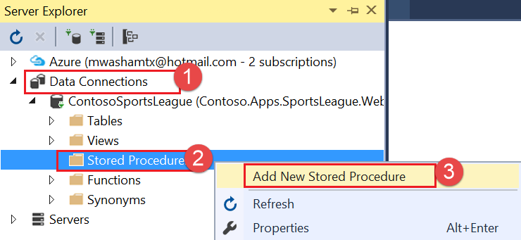

1. Replace the starter code with the following:

This stored procedure will return the count of unprocessed orders.

CREATE PROCEDURE [dbo].[GetUnprocessedOrders]

AS

declare @returnCode int

SELECT @returnCode = COUNT(*) FROM [dbo].[Orders] WHERE PaymentTransactionId is not null AND PaymentTransactionId <> '' AND Phone is not null AND Phone <> '' AND SMSOptIn = '1' AND SMSStatus is null

return @returnCode

1. Click the **SQL** menu in Visual Studio, and then click **Execute**.  
   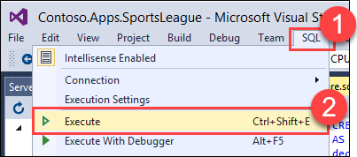
2. Repeat the process using the following code to create the following stored procedure. This stored procedure will update the orders as processed.

CREATE PROCEDURE [dbo].[ProcessOrders]

AS

SELECT * FROM [dbo].[Orders] WHERE PaymentTransactionId is not null AND PaymentTransactionId <> '' AND Phone is not null AND Phone <> '' AND SMSOptIn = '1' AND SMSStatus is null;

UPDATE [dbo].[Orders] SET SMSStatus = 'sent' WHERE PaymentTransactionId is not null AND PaymentTransactionId <> '' AND Phone is not null AND Phone <> '' AND SMSOptIn = '1' AND SMSStatus is null;

1. In the Azure Management Portal, click **+New, Web + mobile,** and then **Logic App.**

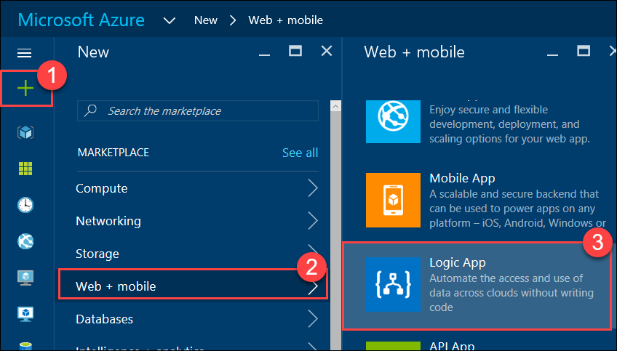

1. On the **Create logic app** blade, assign a value for **Name**, and set the Resource Group to **contososports**.

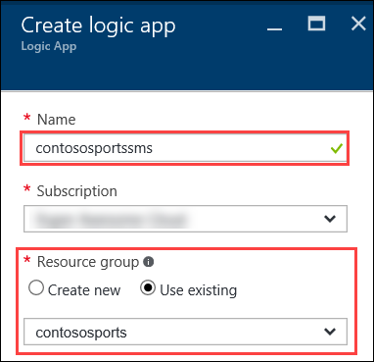

1. Open the Logic App by clicking **More services -> Logic Apps**, and click the Logic App just created.



1. Select the **Blank LogicApp** Template.  
   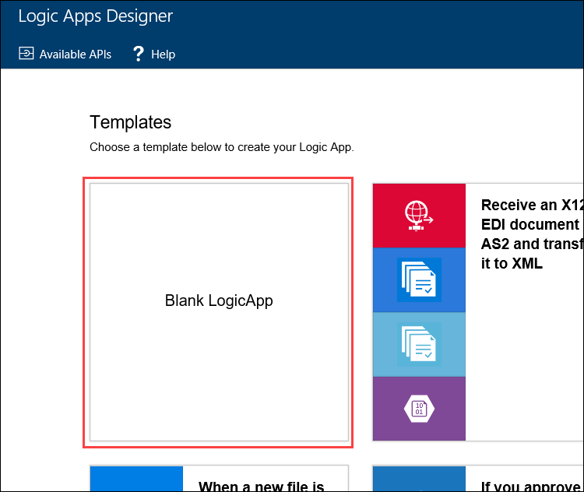
2. On the **Logic Apps Designer**, click **Recurrence**.   
    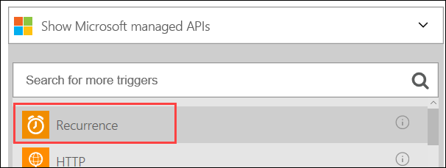
3. Set the **FREQUENCY** to **MINUTE**, and **INTERVAL** to **1**.

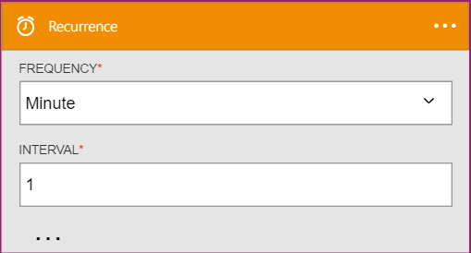

1. Click the **New Step**, and then click **Add an action**.

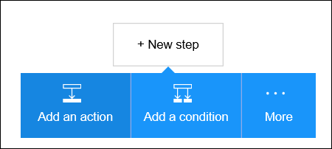

1. Select the **SQL Server – Execute stored procedure** action.

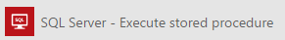

1. The first time you add a SQL action you will be prompted for the connection information. Name the connection **ContosoSportsDB**, and input the server and database details used earlier, and then click **Create**.   
   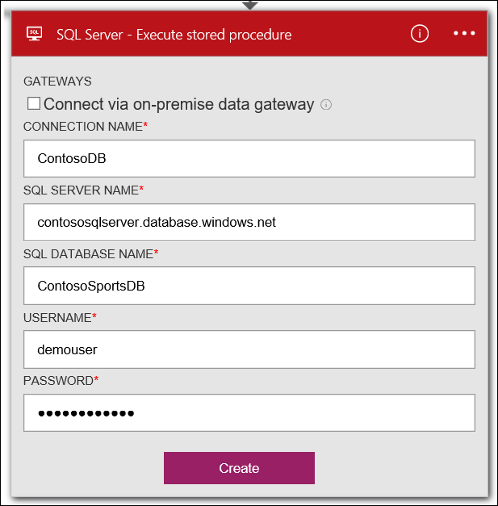
2. Specify the **GetUnprocessedOrders** stored procedure from the drop down.

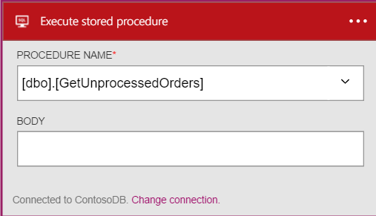

1. Click on **New Step** and click the **Add a condition** link.

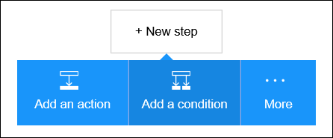

1. Specify **ReturnCode** for the OBJECT NAME, set the RELATIONSHIP to **is greater than**, and set the VALUE to **0**.

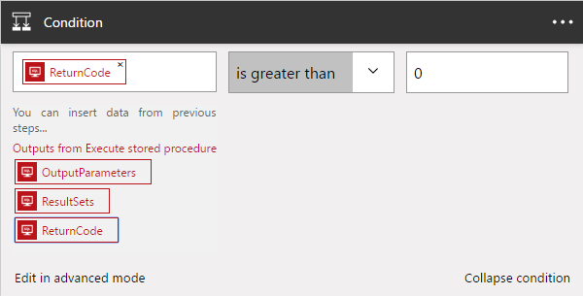

1. Click the **Add an action** link on the If yes condition.

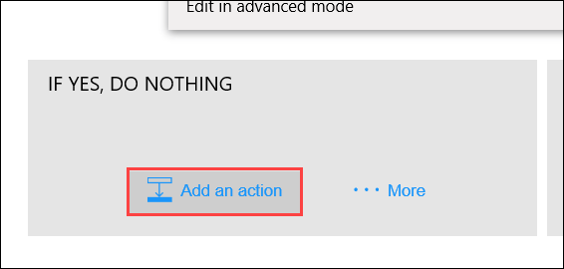

1. Choose the Execute stored procedure action.



1. Select the **ProcessOrders** stored procedure.

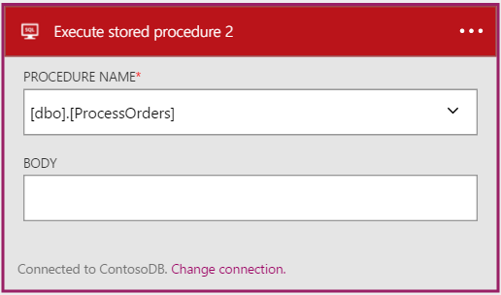

1. Click the **Add an action** link.

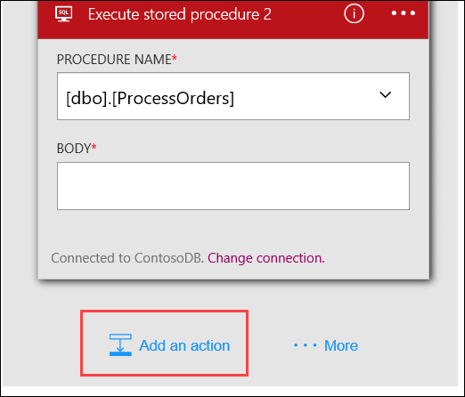

1. Click the **Twilio – Send Text Message** API.



1. Specify your Twilio **Account SID** and **Authentication Token**, and then click the **Create** button.

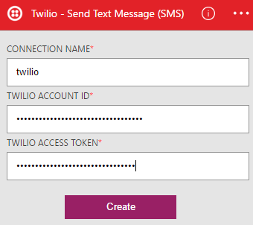

1. Using the drop down, select your Twilio number for the **FROM PHONE NUMBER** field. Specify a placeholder phone number in the **TO PHONE NUMBER**, and a **TEXT** message.  
   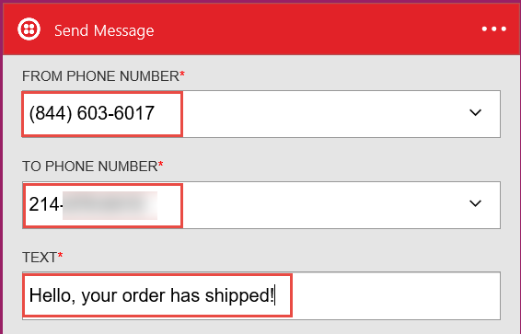
2. On the Logic App tool bar, click the **Code View** button.

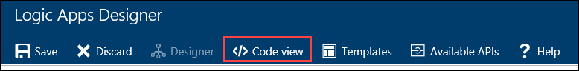

1. Find the **Send_Text_Message_(SMS)** action, then modify the body property of the Twilio action:

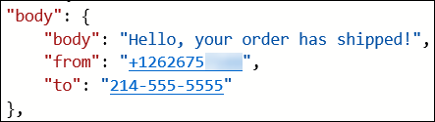

1. Add the following code between Hello and the comma.

**@{item()['FirstName']}**

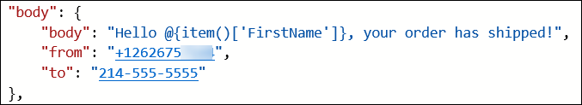

1. Modify the **to** property to pull the phone number from the item.

**@{item()['Phone']}**

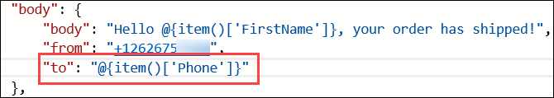

1. Immediately before the **Send_Text_Message_(SMS)** create a new line and add the following code:

"forEach_email": {

"type": "Foreach",

"foreach": "@body('Execute_stored_procedure_2')['ResultSets']['Table1']",

"actions": {

1. Remove the **runAfter** block from the **Send_Text_Message_(SMS)** action.  
   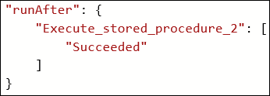
2. Locating the closing bracket of the **Send_Text_Message_(SMS)** action, then create a new line after it and add the following code:

},

"runAfter": {

"Execute_stored_procedure_2": [

"Succeeded"

]

}

}

1. After the code for the **Send_Text_Message_(SMS)** has been modified to be contained within the **forEach_email** action, it should look like the following:

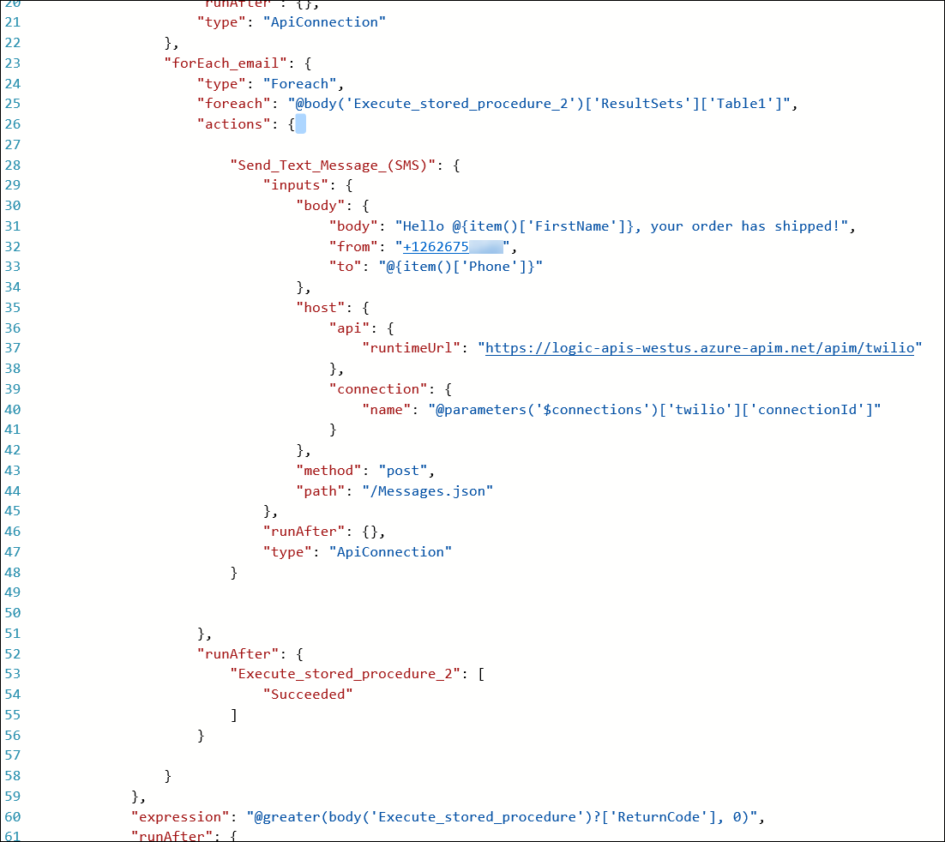

1. Click **Save** on the toolbar to enable the logic app.

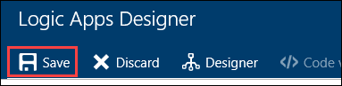

1. Your workflow should look like below, and you should receive a text for each order you have placed   
   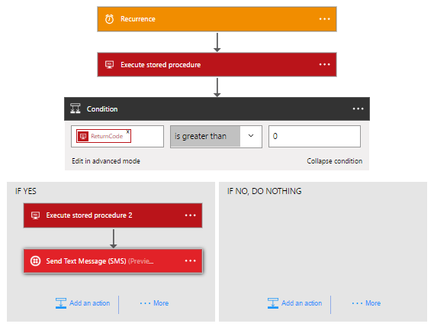

## Exercise 3: Enabling Telemetry with Application Insights

### Overview

To configure the application for logging and diagnostics, you have been asked to configure Microsoft Azure Application Insights and add some custom telemetry.

### Help references

|  |  |
| --- | --- |
| Run performance tests on your app | <http://blogs.msdn.com/b/visualstudioalm/archive/2015/09/15/announcing-public-preview-for-performance-load-testing-of-azure-webapp.aspx> |
| Application Insights Custom Events | <https://azure.microsoft.com/en-us/documentation/articles/app-insights-api-custom-events-metrics/> |
| Enabling Application Insights | <https://azure.microsoft.com/en-us/documentation/articles/app-insights-start-monitoring-app-health-usage/> |
| Detect failures | <https://azure.microsoft.com/en-us/documentation/articles/app-insights-asp-net-exceptions/> |
| Monitor performance problems | <https://azure.microsoft.com/en-us/documentation/articles/app-insights-web-monitor-performance/> |

### Task 1: Configure the application for telemetry

#### Subtask 1: Add Application Insights Telemetry to the e-commerce website project

1. Open the Solution **Contoso.Apps.SportsLeague** in Visual Studio.
2. Navigate to the **Contoso.Apps.SportsLeague.Web** project located in the **Web** folder using the **Solution Explorer** in Visual Studio.



1. Right-click the **Contoso.Apps.SportsLeague.Web** project and select **Add Application Insights Telemetry**.

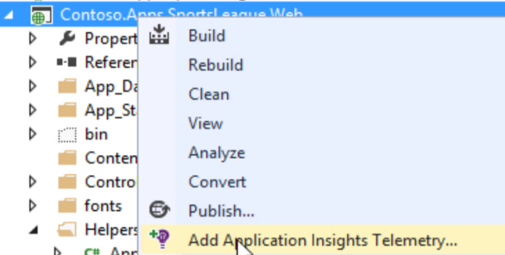

1. On the **Application Insights** dialog box, select the “*(New resource)*” option, then click **Add**.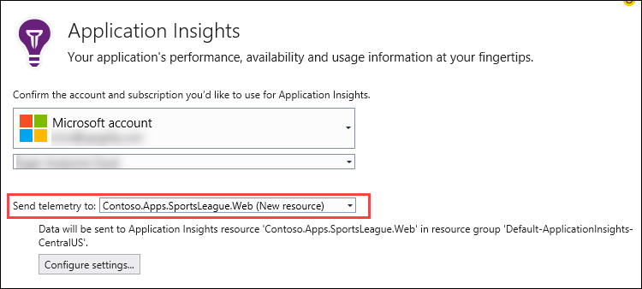
2. Once it completes, it displays the following Output and opens a new browser window

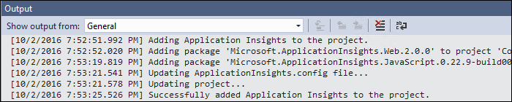

1. Open the file **\Helpers\TelemetryHelper.cs** located in the **Contoso.Apps.SportsLeague.Web** project.
2. Add the following using statement to the top of the file:

using Microsoft.ApplicationInsights;

1. Add the following code to the TrackException method to instantiate the telemetry client and track exceptions.

*var client = new TelemetryClient();*

*client.TrackException(new Microsoft.ApplicationInsights.DataContracts.ExceptionTelemetry(exc));*

1. Add the following code to the TrackEvent method to instantiate the telemetry client and track event data.

*var client = new TelemetryClient();*

*client.TrackEvent(eventName, properties);*

1. Save the **TelemetryHelper.cs** file.

#### Subtask 2: Enable client side telemetry

1. Open the Azure Management Portal (<http://portal.azure.com>). Click **More services**, and then click **Application Insights**.

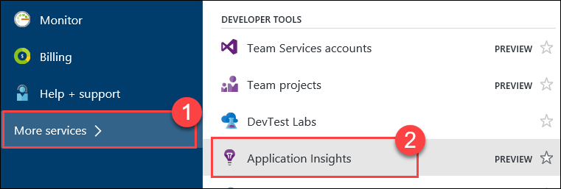

1. Click the Application Insights instance associated with the Contoso E-Commerce Site.

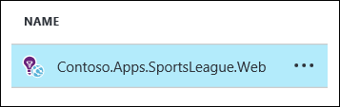

1. In settings menu click **Getting Started**.

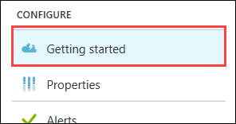

1. Next, click the **MONITOR AND DIAGNOSE CLIENT SIDE APPLICATION** arrow.**🡪**This will open the **Client application monitoring and diagnosis** blade.  
   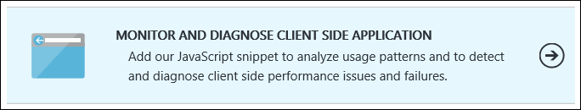
2. Select and copy the full contents of the JavaScript on the **Client application monitoring and diagnosis** blade.

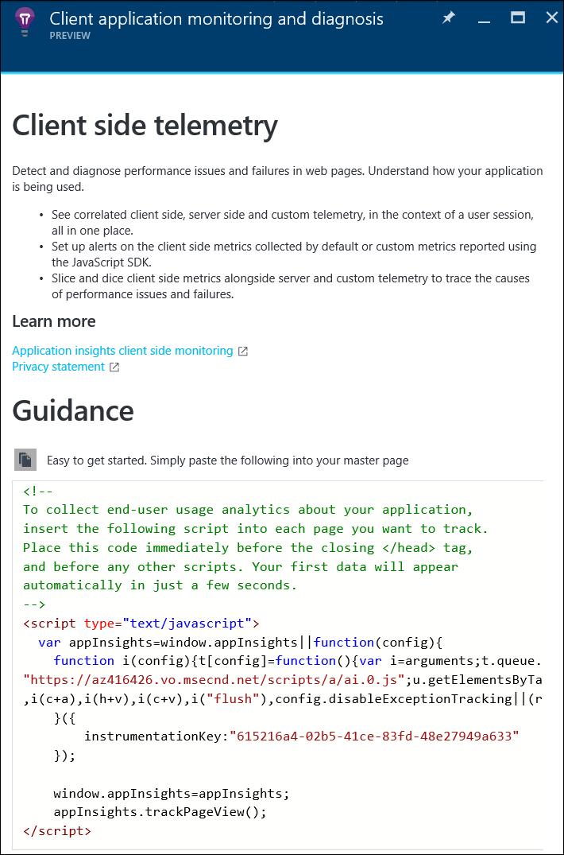

1. Navigate to the **Contoso.Apps.SportsLeague.Web** project located in the **Web** folder using the **Solution Explorer** in Visual Studio.
2. Open **Views > Shared > _Layout.cshtml**.

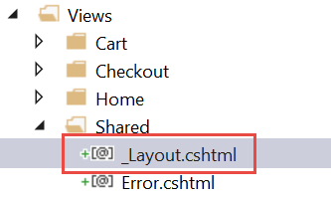

1. Paste in the code before the **</head>** tag.

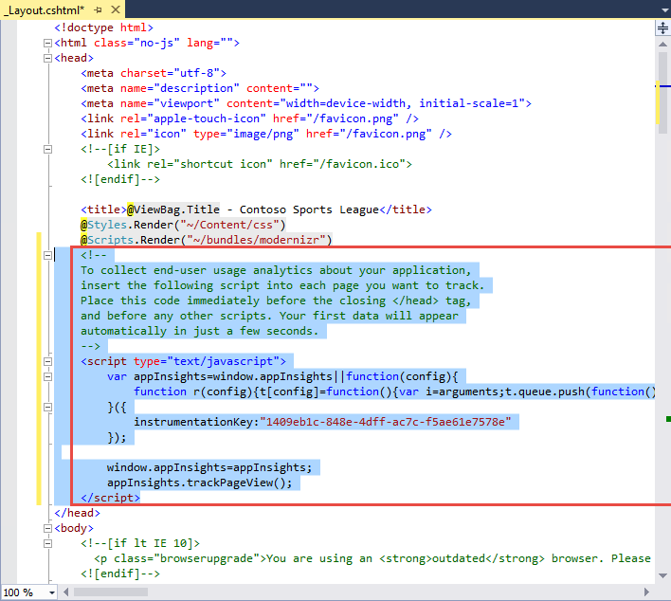

1. Save the **_Layout.cshtml** file.

#### Subtask 3: Deploy the e-commerce web app from Visual Studio

1. Navigate to the **Contoso.Apps.SportsLeague.Web** project located in the **Web** folder using the **Solution Explorer** in Visual Studio.



1. Right-click the **Contoso.Apps.SportsLeague.Web** project and select **Publish**.



1. Click **Publish** again when the Publish dialog appears.
2. Click a few links on the published E-Commerce web site and submit several orders to generate some sample telemetry.

### Task 2: Creating the web performance test and load test

#### Subtask 1: Create the load test

1. Open the Azure Management Portal (<http://portal.azure.com>). Click **More services**, and then click **Application Insights**.



1. Click the Application Insights instance associated with the Contoso E-Commerce Site.



1. Click **Performance Testing**.

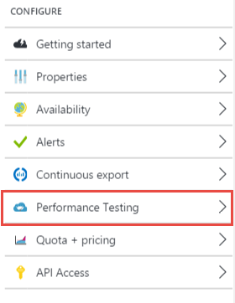

1. Click the Set Account button to associate/create a Visual Studio Team Services account.

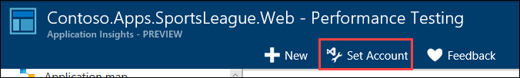

1. On the Account tile, click **Or Create New**.

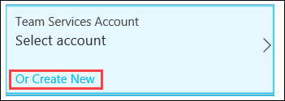

1. Specify a unique name for the account and select a region. Note the region may differ from the region you have deployed your resources.

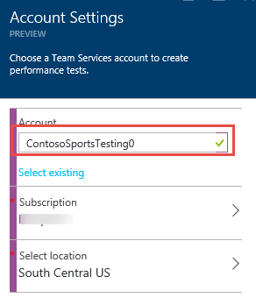

1. Click **Subscription**, and then select your Subscription.  
   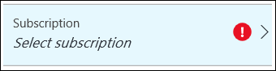
2. Click **Select location**, and then select a Location.  
   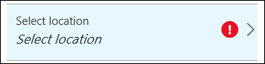
3. Click **OK**

The VSTS account creation will take a minute to complete.

1. Click **New.**

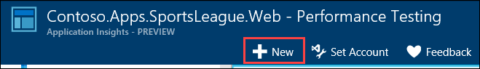

1. Click on **Configure Test Using**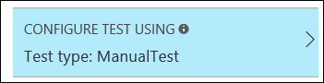
2. Specify the **URL** to the Contoso E-Commerce site, and then click **Done**  
   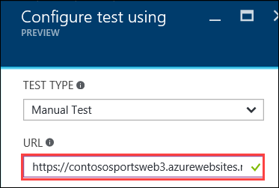
3. Name the test **ContosoSportsTest**, then click the **Run test** button.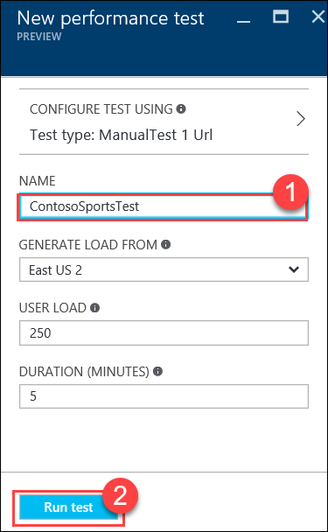
4. Wait until the load test has completed.

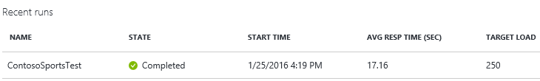

#### Subtask 2: View the Application Insights logs

1. Using a new tab or instance of your browser navigate to the Azure Management portal <http://portal.azure.com>.
2. On the left menu area, click **More services**.
3. On the **More services** blade select **Application Insights**.
4. On the **Application Insights** blade, select the Application Insights configuration you created for the e-commerce website.

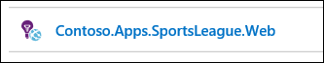

1. View the performance timeline to see the overall number of requests and page load time.

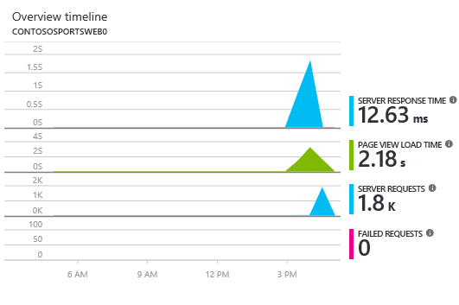

1. Under Settings, click **Usage**.

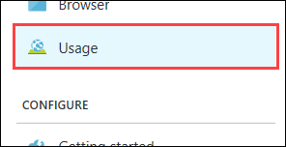

1. After several minutes you should see several Custom events from your previous order testing. This is reported through the TelemetryClient’s TrackEvent method.

Note: If you do not see data here come back later after the lab is complete.

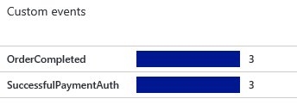

1. Drilling into the OrderCompleted events provides you with more detail about the specific order.   
   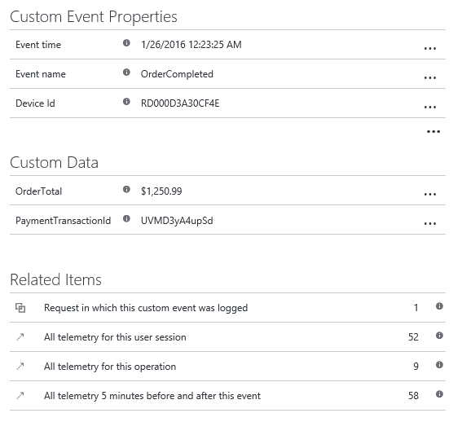

## Exercise 4: Identity and security

### Overview

The Contoso call center admin application will only be accessible by users of the Contoso Active Directory environment. You have been asked to create a new Azure AD Tenant and secure the application so only users from the tenant can log on.

### Help references

|  |  |
| --- | --- |
| What is Azure AD? | <https://azure.microsoft.com/en-us/documentation/articles/active-directory-whatis/> |
| Azure Web Apps authentication | <http://azure.microsoft.com/blog/2014/11/13/azure-websites-authentication-authorization/> |
| View your access and usage reports | <https://msdn.microsoft.com/en-us/library/azure/dn283934.aspx> |
| Custom branding an Azure AD Tenant | <https://msdn.microsoft.com/en-us/library/azure/Dn532270.aspx> |

Note: Tasks 1, 2, and 4 are optional and require global admin permissions on the AzureAD Tenant. Task 3 is also optional, but does require the permission to create an app in the Azure AD tenant.

### Task 1: Enable Azure AD Premium Trial

Note: this task is optional and is valid only if you are a global administrator on the Azure AD tenant associated with your subscription.

1. Open the Azure Classic Portal by launching a browser and navigating to <https://manage.windowsazure.com>.
2. If you have more than one Azure AD tenant in your subscription, click **SETTINGS**, and view your subscription. The value in the **DIRECTORY** column is the subscription to use in the next step.
3. On the **active directory** page, select the **arrow** next to the name of the Azure Active Directory Tenant associated with your subscription. 
4. On the **Quickstart** page for your Azure Active Directory Tenant click the **Try it now** button under **Get Azure AD Premium**.

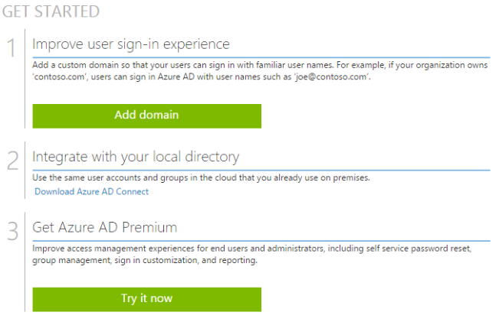

1. On the next page, click the **Try Azure Active Directory Premium Now** link.

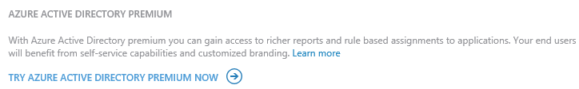

1. On the **Activate Azure AD Premium trial** dialog box, select the circled check mark to confirm your choice.

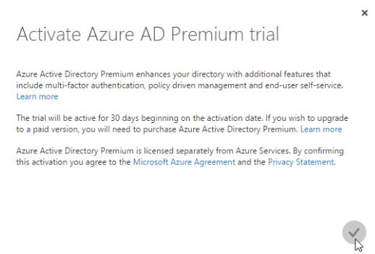

1. On the next page, you will see a message to wait while the trial is set up.

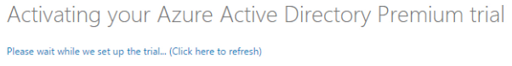

Note: If it does not advance to the next step, click (Click here to refresh).

1. When the setup completes you will see that the Azure Active Directory Premium is included in the License Plans for your Azure Active Directory Tenant.

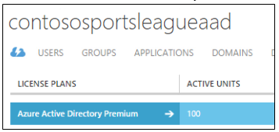

### Task 2: Create a new Contoso user

Note: this task is optional and is valid only if you are a global administrator on the Azure AD tenant associated with your subscription.

1. Within your new Active Directory Tenant, click **Users**.



1. Click **Add User**.  
   
2. Specify the user’s **User Name** and click the circled **next arrow** to continue.   
   Note the full user account for later use.   
   **Example:** contosouser@[your tenant].onmicrosoft.com.

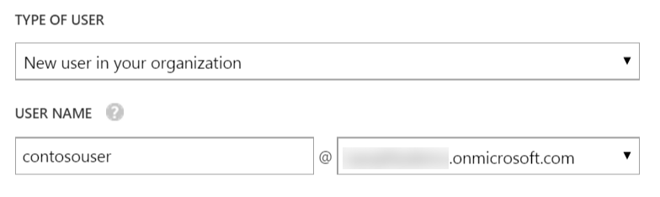

1. Specify user information for your user and click the **next arrow** to continue.

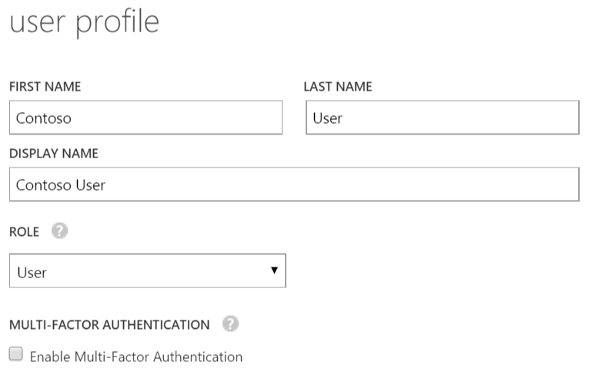

1. Click **Create** and note the temporary password for later reference.



1. Select the circled check mark to finish.

### Task 3: Configure access control for the call center administration web application

Note: this task is optional and is valid only if you have the right to create applications in your Azure AD Tenant.

1. Open the Azure Management Portal <https://portal.azure.com>
2. On the left navigation, click **App Services** (or click Browse and then click **App Services**.



1. On the **web apps** page select the **call center administration web app**.

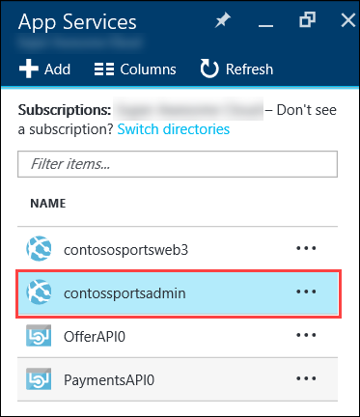

1. Click the **Authentication / Authorization** tile.

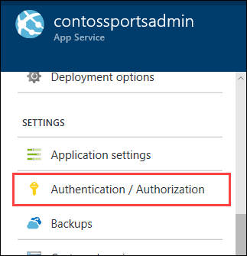

1. Change **App Service Authentication to On**, change the dropdown to **Log in with Azure Active Directory**, and click the **Azure Active Directory Authentication Provider**.

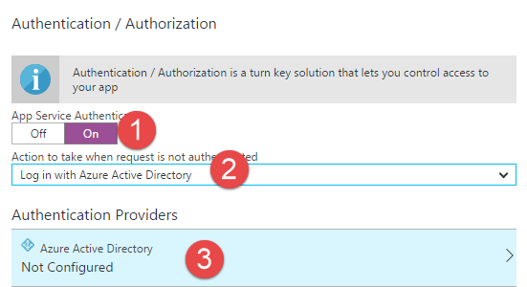

1. Change **Management mode** to **Express**, and then click **OK**.

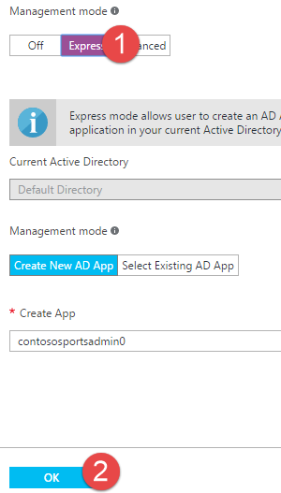

1. In the **Authentication / Authorization** blade click **Save**.

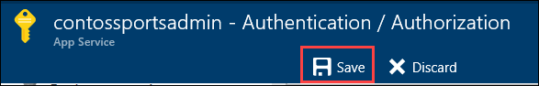

#### Subtask 2: Verify the call center administration website uses the access control logon

1. Close your browser (or use an alternative) and launch a browser is InPrivate or Incognito mode. Navigate to the **call center administration** website.
2. The browser will redirect to the non-branded Access Control logon URL. You can log on with your Microsoft account or the Contoso test user you created earlier.

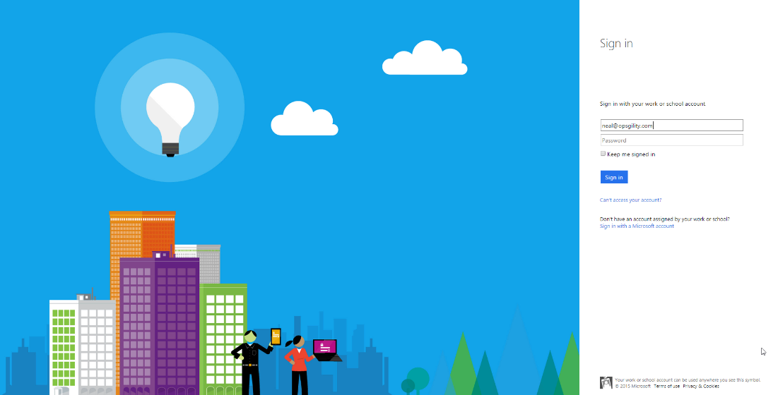

1. After you log on, your browser will be redirected to the Contoso Sports League Admin web page.

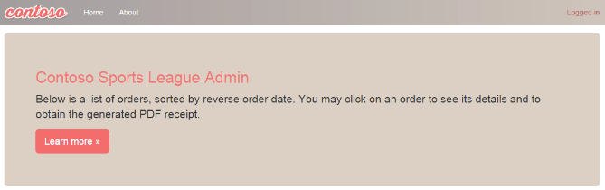

1. Verify that in the upper-right corner you see the link **Logged In**. If it is not configured you will see **Sign in**.

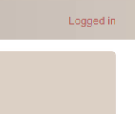 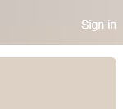

### Task 4: Apply custom branding for the Azure Active Directory logon page

Note: this task is optional and is valid only if you are a global administrator on the Azure AD tenant associated with your subscription and you completed the Enabling Azure AD Premium exercise.

1. Using a new tab or instance of your browser navigate to the management portal <http://manage.windowsazure.com> and log on.
2. On the left menu bar, click **Active Directory**.

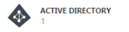

1. On the **active directory** page, click the **arrow** next to the name of the Azure Active Directory Tenant configured in the previous exercise.
2. On the Azure Active Directory Tenant page, click the **Configure** link.



1. In the directory properties section, click the **Customize Branding** button.

Proctor Note: The attendee may need to refresh the browser to see the Customize Branding button.

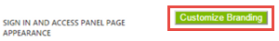

1. On the **Customize Default Branding** dialog box, browse to the images in the **C:\Hackathon** folder for each input section. Choose the images as in the screenshot below. Click the **circled arrow** in the lower-right corner to continue. On page 2, finish filling in the dialog box and click the **circled check mark** in the lower-right corner to complete.

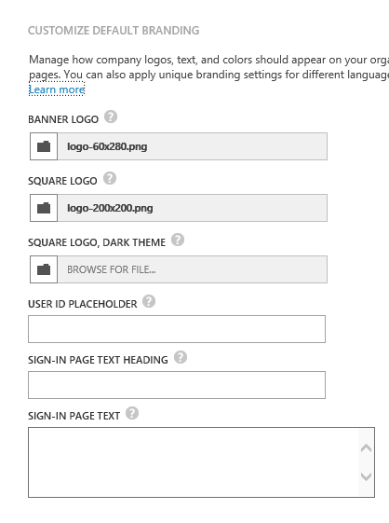 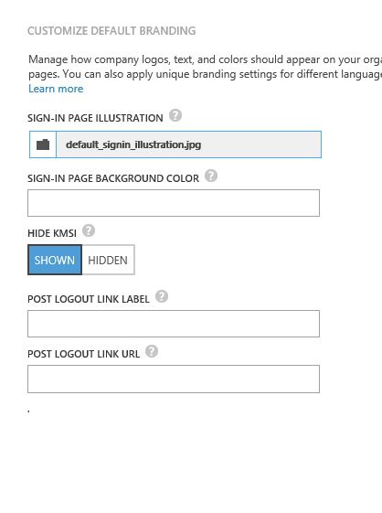

1. Wait for the management portal to confirm the branding changes have successfully saved.

#### Subtask 2: Verify the branding has been successfully applied to the Azure Active Directory logon page

1. Close any previously authenticated browser sessions to the call center administration web site, re-open using InPrivate or Incognito mode, and navigate to the **call center administration** website.
2. The browser will redirect to the branded access control logon URL.

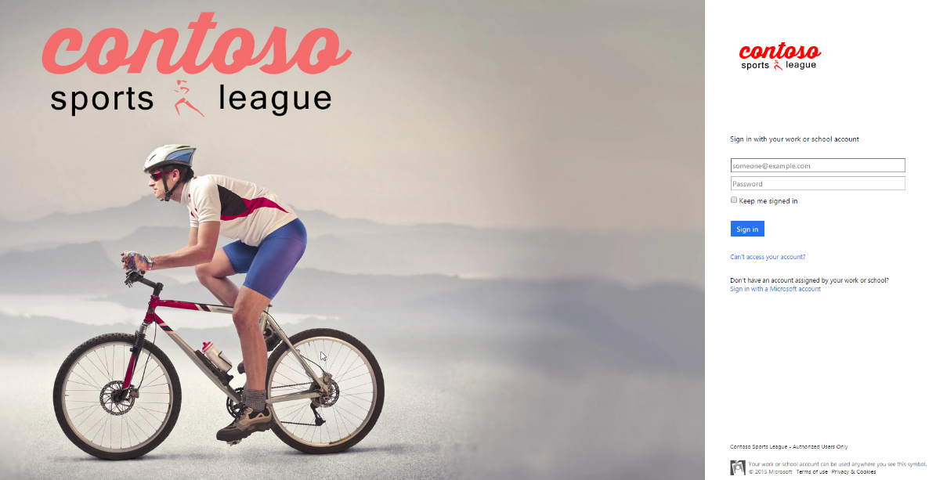

1. After you log on your browser will be redirected to the Contoso Sports League Admin web page.



1. Verify that in the upper-right corner you see the link **Logged in**.



## Exercise 5: SQL Data Warehouse

### Overview

Contoso wants to setup a SQL Data Warehouse in Microsoft Azure to enable data analytics capabilities.

### Help references

|  |  |
| --- | --- |
| Create an Azure SQL Data Warehouse | <https://azure.microsoft.com/en-us/documentation/articles/sql-data-warehouse-get-started-provision/> |
| SQL Data Warehouse Migration Utility | <https://azure.microsoft.com/en-us/documentation/articles/sql-data-warehouse-migrate-migration-utility/> |
| Introduction to Azure Data Factory Service | <https://azure.microsoft.com/en-us/documentation/articles/data-factory-introduction/> |

### Task 1: Create SQL Data Warehouse

In this exercise, you will provision a SQL Data Warehouse using the Microsoft Azure Portal.

#### Subtask 1: Create SQL Data Warehouse

1. Navigate to the Azure Management Portal <http://portal.azure.com>, using a new tab or browser instance
2. Click **+New**, select **Databases**, then **SQL Data Warehouse**.  
   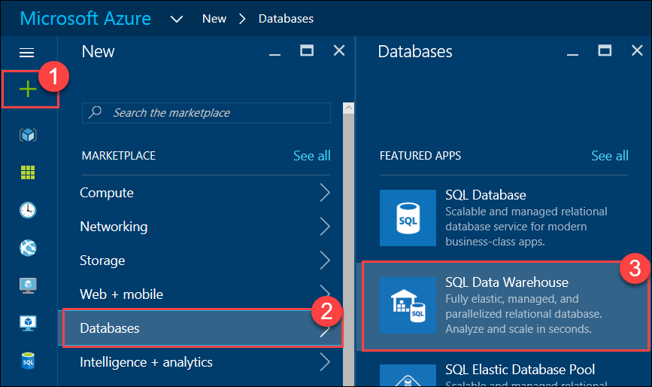
3. On the **SQL Data Warehouse** blade, specify the following configuration:
   1. Specify **ContosoSportsDWDB** as the Database name
   2. Specify the **contososports** Resource group.
   3. Specify **100 DWU** for the Performance  
      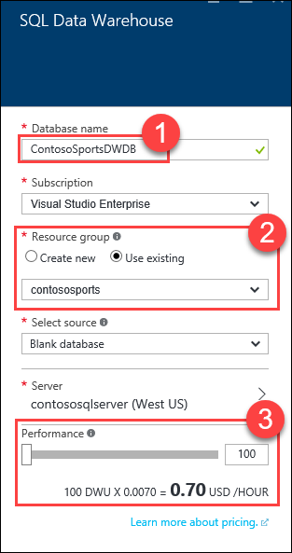
4. Click **Server**, then click **Create a new server**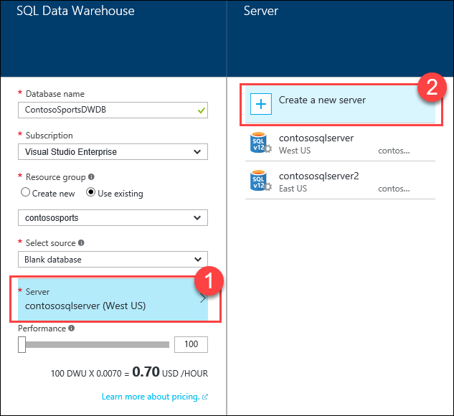
5. On the **New server** blade, specify the following configuration
   1. Server name: a unique value (ensure the green checkmark appears)
   2. Server admin login: **demouser**
   3. **Password** and  **Confirm Password**: demo@pass123
   4. Ensure the **Location** is the same region as the SQL Database for the Web App  
      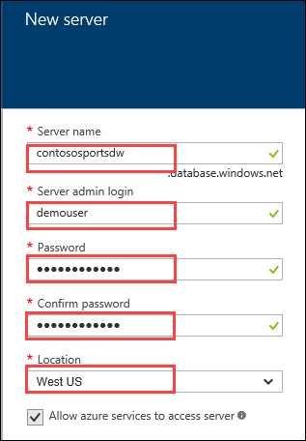
6. Click **Select**
7. On the **SQL Data Warehouse** blade, click **Create**

#### Subtask 2: Initialize SQL Data Warehouse database

1. Download and Install the Data Warehouse Migration Utility  
   <https://azure.microsoft.com/en-us/documentation/articles/sql-data-warehouse-migrate-migration-utility/>
2. Run the Data Warehouse Migration Utility (DataSourceMigrationEngine.exe)

The utility is installed into the following folder:  
*C:\Program Files (x86)\Data Warehouse Migration Utility*

Also, an Icon to run the utility will be placed on the Desktop.

1. In the Migration Utility specify the **Azure SQL Database** Source Type, and click **Next**.  
   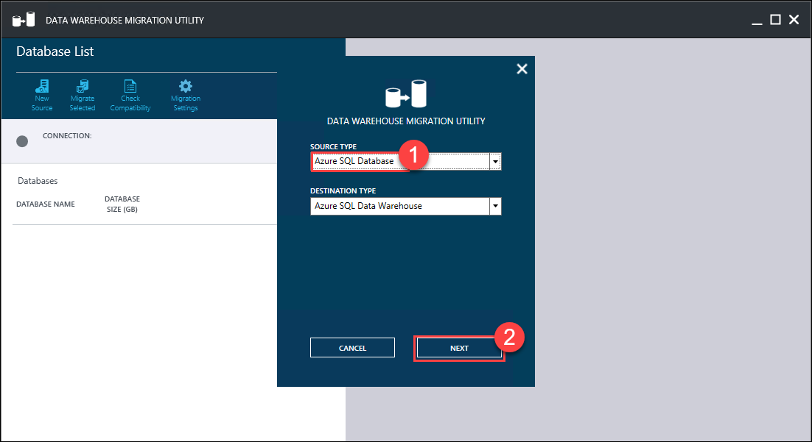
2. In the **Migration Source** step, specify the following configuration:
   1. Specify the **Server name** of the Azure SQL database server; this needs to be the full server DNS name: *{server name}.database.windows.net*
   2. Specify the **User Name** to login to the server: demouser
   3. Specify the **Password** to login to the server: demo@pass123  
        
      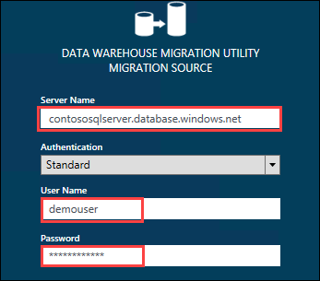
3. Click **CONNECT**
4. Select the database, then click the **Migrate Selected** button  
   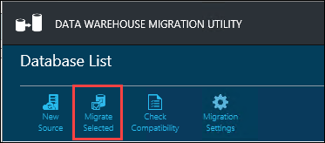
5. In the **Migrate Database** pane, select the **dbo.Orders** and **dbo.OrderDetails** tables  
   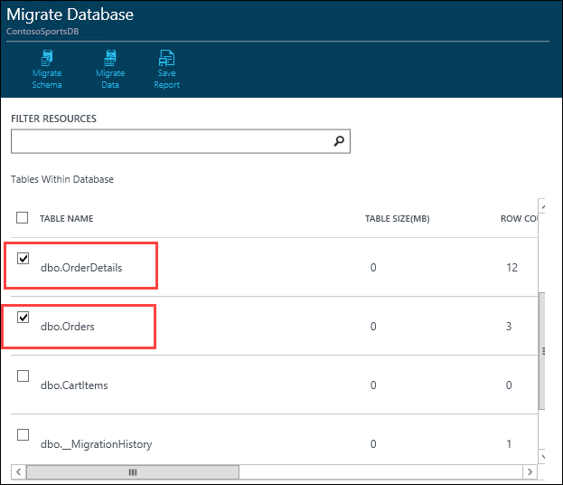
6. Click the **Migrate Schema** button  
   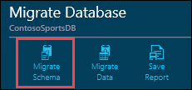
7. On the **Migrate** Schema pane, click the **Run Script** button  
   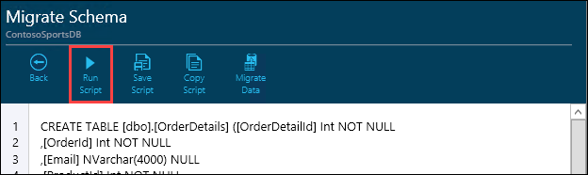
8. In the **Migration Destination** dialog, specify the following configuration:
   1. Specify the **Server name** of the Azure SQL Data Warehouse server; this needs to be the full server DNS name: {server name}.database.windows.net
   2. Specify the **User Name** to login to the server: demouser
   3. Specify the **Password** to login to the server: demo@pass123  
        
      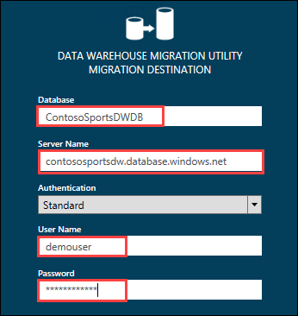
9. Click **OK**
10. Click **OK** on the **Script Applied Successfully** prompt  
    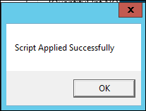
11. Click the **Migrate Data** button  
    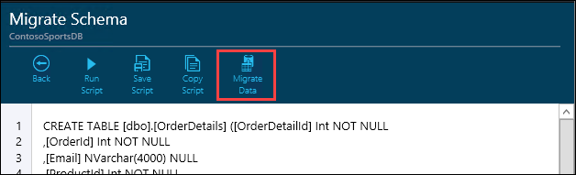
12. Click the **Run Migration** button  
    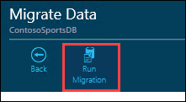
13. On the **Data Warehouse Migration Utility** dialog, click **Next**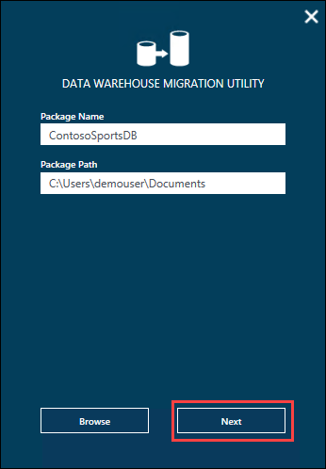
14. Click the **Generate** button  
    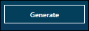
15. Click **OK** on the **Package(s) Generated Successfully** prompt  
    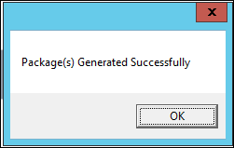

This will generate two .bat scripts for exporting the data and then importing it into the SQL Data Warehouse using BCP.

1. Open a **Command Prompt** window and change location the **Package Path** where the packages were generated.  
   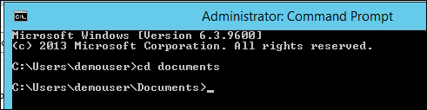
2. Run the **ContosoSportsDB_Export.bat** script  
   
3. Run the **ContosoSportsDB_Import.bat** script  
   

### Task 2: Configure Azure Data Factory

In this exercise, you will provision an Azure Data Factory using the Microsoft Azure Portal. You will then configure a Pipeline to archive data from the applications SQL Database into the SQL Data Warehouse you created previously.

#### Subtask 1: Create Azure Data Factory

1. Navigate to the Azure Management Portal <http://portal.azure.com>, using a new tab or browser instance
2. Click **+New**, select the **Intelligence + analytics**, then **Data Factory**  
   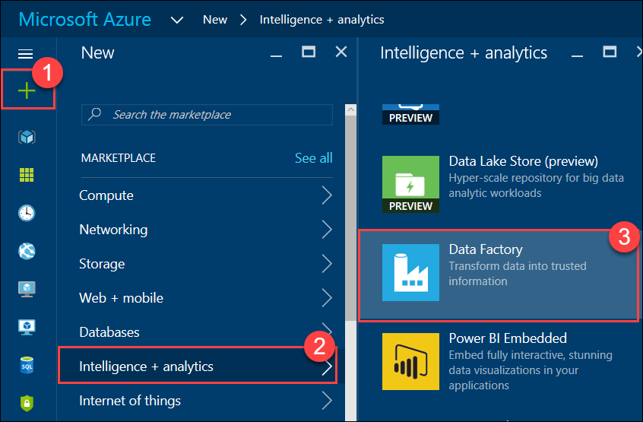
3. On the **New data factory** blade, specify the following configuration:   
   1. Specify **ContosoSportsDataFactory** as the Name
   2. Specify the **contososports** Resource group
   3. Ensure the **Location** is the same region as the SQL Data Warehouse  
      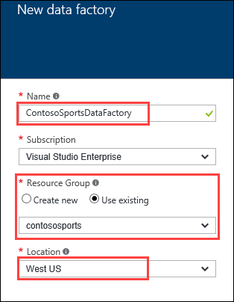
4. Click **Create**

#### Subtask 2: Configure Pipeline

1. Navigate to the Azure Management Portal <http://portal.azure.com>, using a new tab or browser instance
2. Click **More services**, **Data factories**, and then click the name of the Data Factory you created previously
3. On the **Data factory** blade, click **Copy data**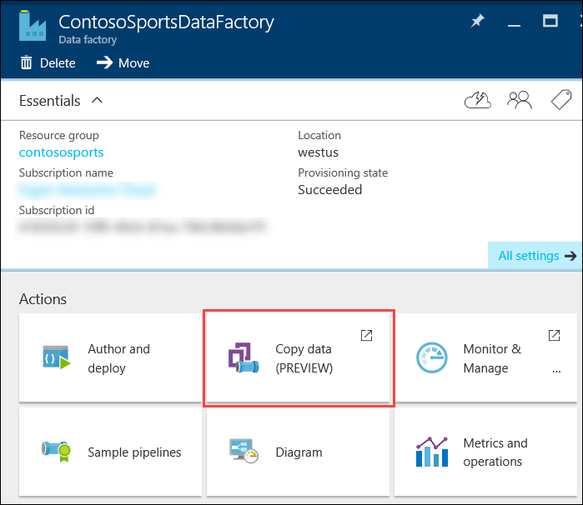

Clicking Copy data will open up the Data Factory tool in a new browser window.

1. Update the **Recurring pattern** to run every 15 minutes, and click **Next**  
   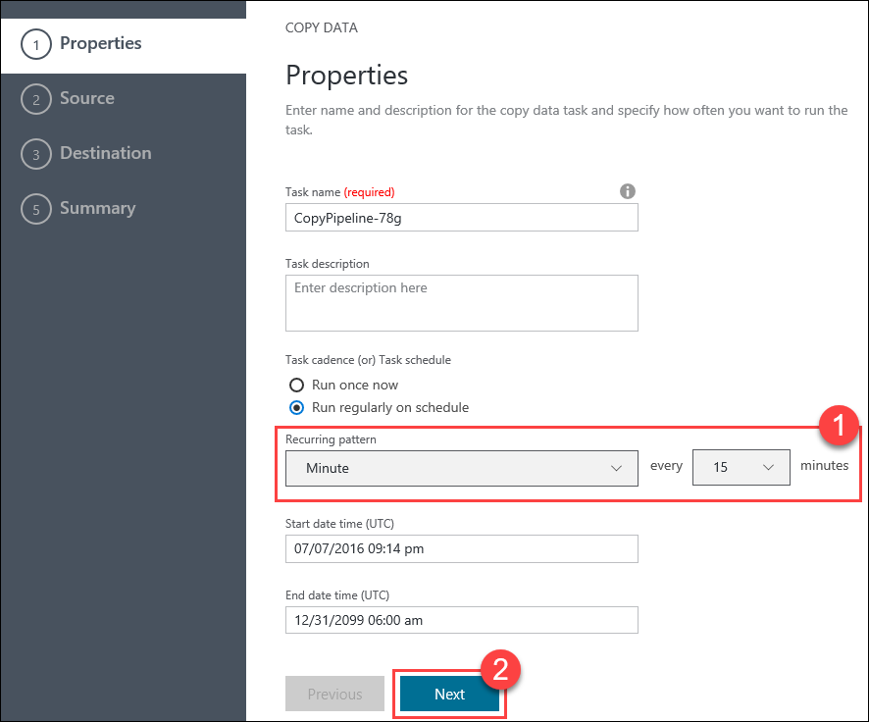
2. Select the **Azure SQL Database** data source, and click **Next**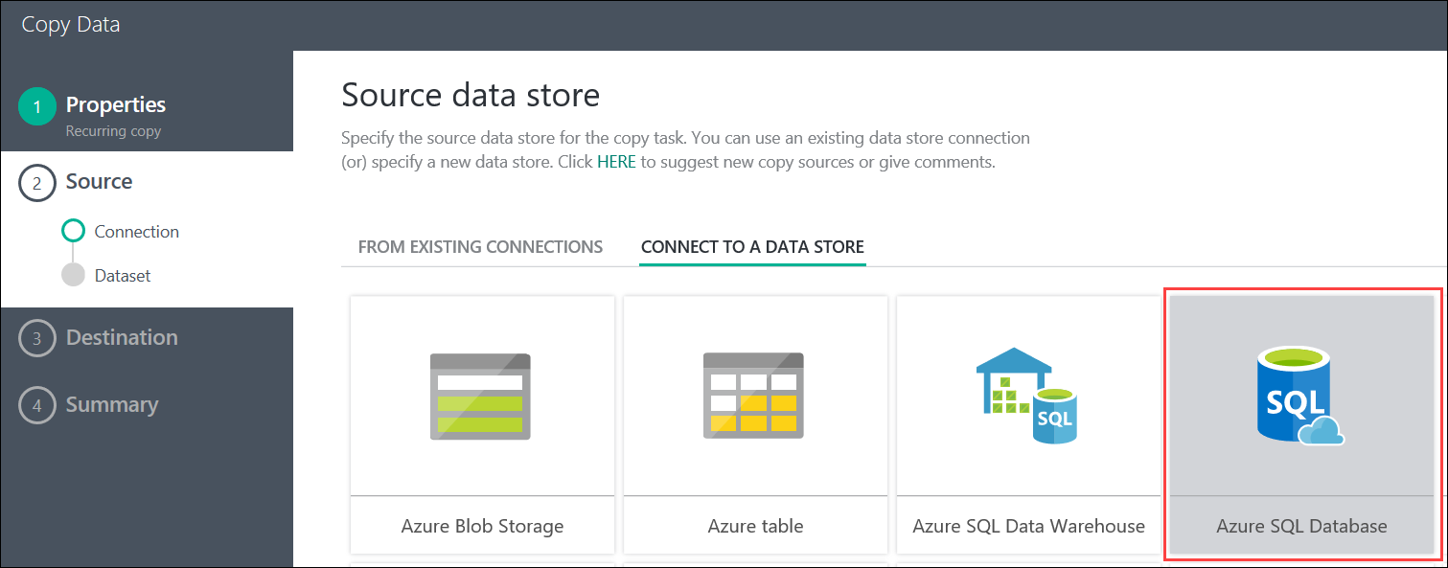
3. On the **Specify the Azure SQL database** step, specify the following configuration:
   1. Specify the **SQL Database Server** that contains the SQL database for the Web App
   2. Specify the **ContosoSportsDB** database
   3. Specify the User name for the database server: demouser
   4. Specify the Password for the database server: demo@pass123

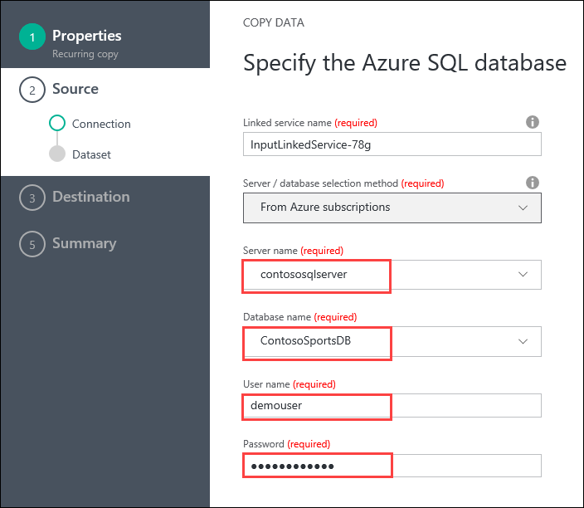

1. Click **Next**



1. Select the **Orders** and **OrderDetails** tables in the list of Existing Table, then click **Next**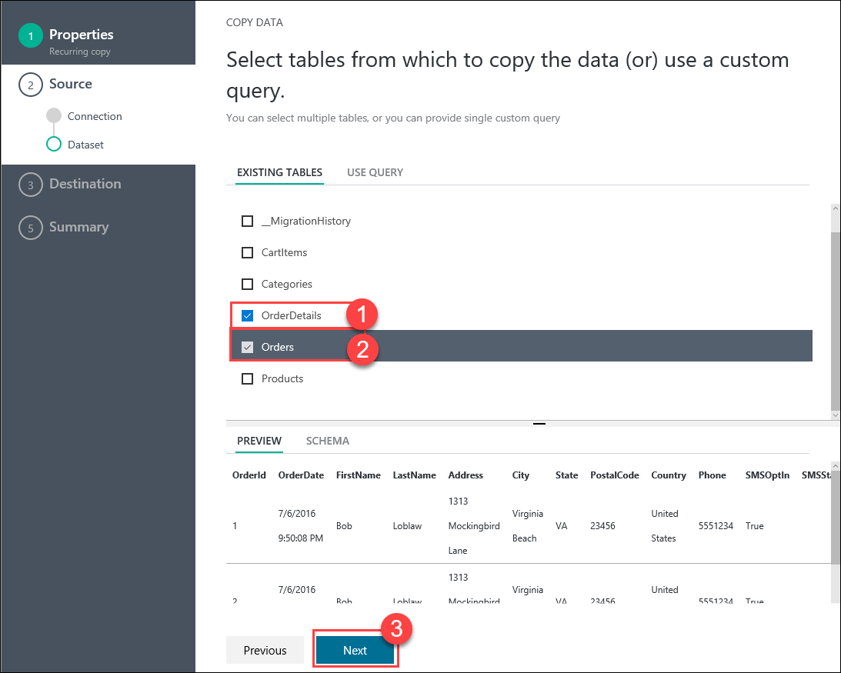
2. On the **Apply filter** step, set the **Orders** filter to **None**, andclick **Next**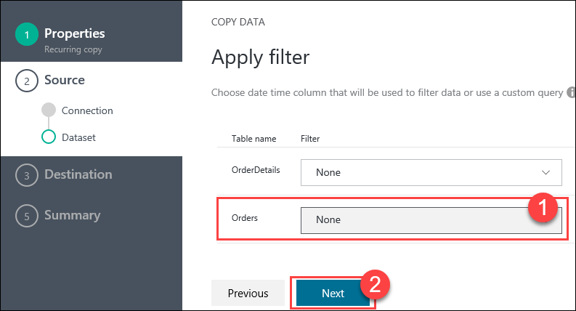
3. On the **Destination data store** step, select **Azure SQL Data Warehouse**, then click **Next**  
   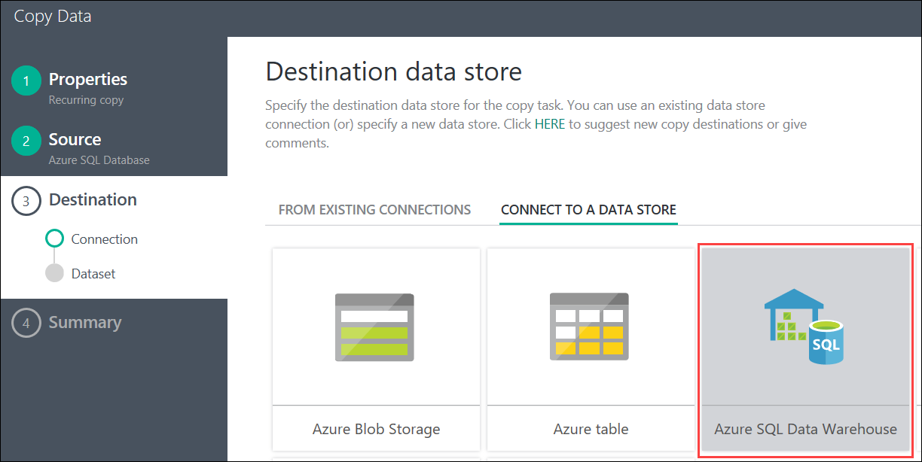
4. Specify the following configuration for the Azure SQL Data Warehouse:
   1. Specify the **Server name** for the SQL Data Warehouse
   2. Specify the **ContosoSportsDWDB** database
   3. Specify the User name for the Data Warehouse server: demouser
   4. Specify the Password for the Data Warehouse server: demo@pass123  
      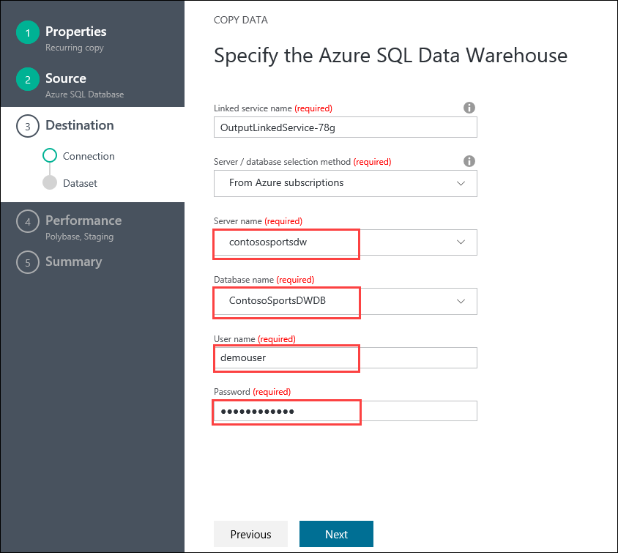
5. Click **Next**
6. On the **Destination Table Mapping** step, specify the following configuration:
   1. Specify the source OrderDetails to map to the **OrderDetails** destination table
   2. Specify the source Orders to map to the **Orders** destination table  
        
      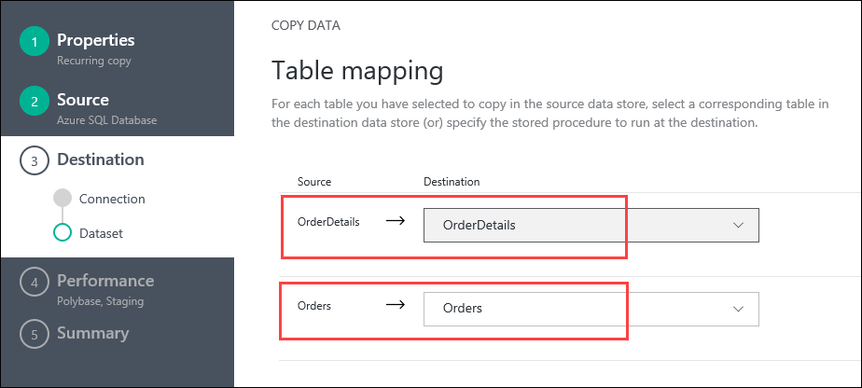
7. Click **Next**
8. On the **Destination Schema mapping** step, select the **OrderDetails** mappings and enter the following configuration:
   1. Set the Method to **Custom script**
   2. Set the Custom script to the following:

delete from OrderDetails

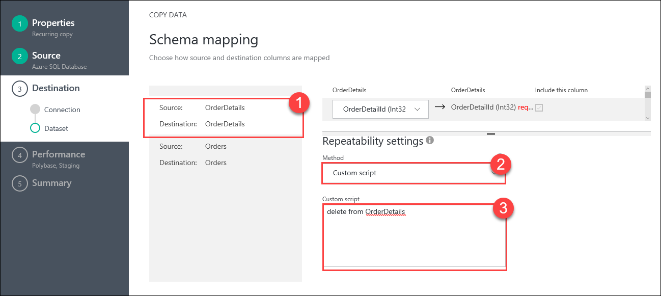

1. Select the **Orders** mappings and enter the following configuration:
   1. Set the Method to **Custom script**
   2. Set the Custom script to the following:

delete from Orders

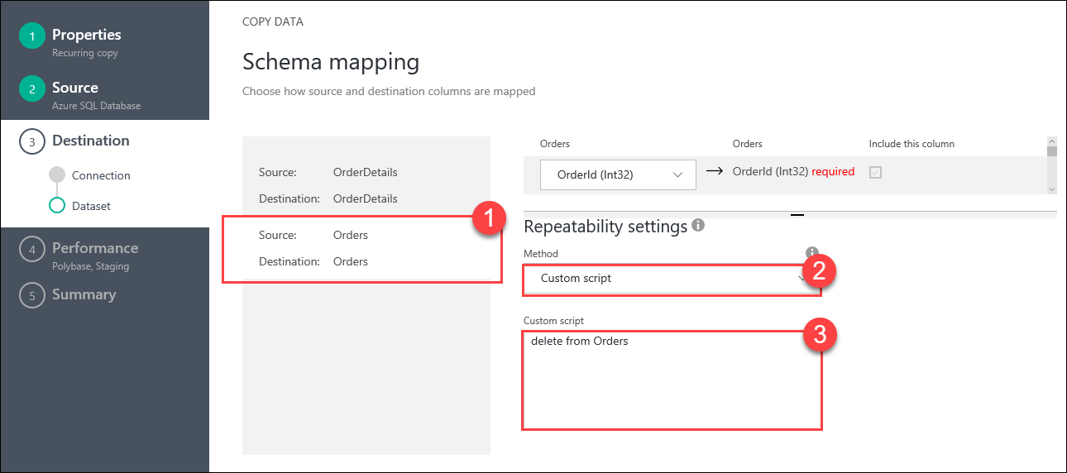

Note: These two DELETE custom scripts will ensure all previous row are deleted from the tables in the SQL Data Warehouse before data is copied over from the SQL Database each time the Pipeline runs.

1. Click **Next**
2. On the **Performance settings** step, uncheck the **Allow polybase** checkbox  
   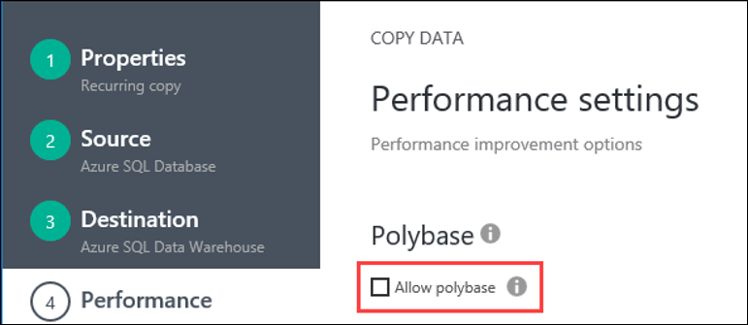

Note: The checkbox must be unchecked. With the current database schema in the web app, if Polybase is allowed then the Pipeline will error that the length of row exceeds maximum allowed for the Orders table data migration.

1. Set the **User staging account** to **New connection**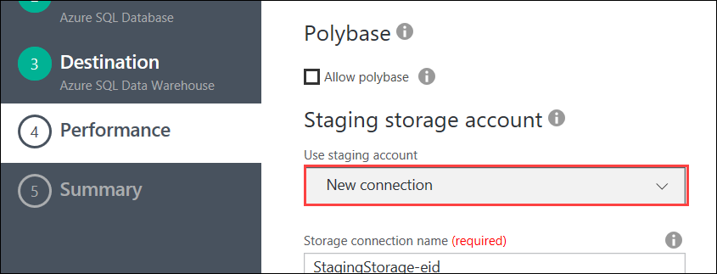
2. For **Staging storage account**, set the **Storage account name** to the Azure Storage Account that was previously created for Web App  
   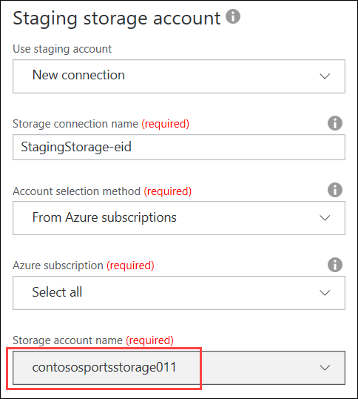
3. Click **Next**  
   
4. On the **Summary** step, click **Finish**